HAMPI
Hampi, a 16-square-mile (40-square-km) site located in Vijayanagara district, Karnataka, India. It sits on the southern bank of the Tungabhadra river. The area comprises more than 1,600 surviving monuments from the former capital city, Vijayanagara (Sanskrit: “City of Victory”), of the Vijayanagara empire, which was founded in 1336. The site contains a wide range of structures: royal and religious enclosures, temples, commemorative monuments, pillared pavilions, animal quarters, and water management installations. In 1986 Hampi was inscribed on the UNESCO World Heritage List. Sri Krishnadevaraya was the king of vijaynagara empire and hampi .

Mythical identity

Hampi has long been associated with legends of the Sanskrit epic Ramayana and Puranic lore (a corpus of Hindu literature comprising myth, legend, and genealogy), which underlie its alternate names Kishkindha‑kshetra and Pampakshetra.
According to Hindu mythology, Kishkindha was the kingdom of monkeys ruled by the monkey king Sugriva. It was here that Rama—the hero of the Ramayana and an avatar of the god Vishnu—and his half-brother Lakshmana first met the monkey god Hanuman while searching for Rama’s wife, Sita. The hills, boulders, and riverbanks around Hampi—including Matanga Hill and Anjanadri Hill—are believed to correspond to landmarks mentioned in the Ramayana.
The name Pampakshetra (“field of Pampa”) refers to Pampa, a local name for the goddess Parvati of Hindu mythology, and is the ancient name of the Tungabhadra river. Hindu lore says that Shiva performed meditation on Hemakuta Hill at Hampi before marrying Pampa, daughter of Brahma. The site is also linked to the destruction of Kama, the god of desire, who disturbed Shiva’s meditation in support of Pampa’s wish to marry Shiva. Enraged, Shiva burnt Kama to ashes with his third eye at this spot.

Architectural styles
Hampi’s monuments reflect centuries of cultural blending, drawing from three major architectural influences—Dravidian, Indo-Islamic, and Vijayanagara.
Dravidian architecture features massive structures with secluded enclosures, walls embellished with sculpted motifs, tall towers, and entryways framed by ornamental pillars. Classic examples of Dravidian-style structures include the Virupaksha Temple and the Vittala Temple.Indo-Islamic architecture is often characterized by symmetrical arches and domes and decorative paneling, such as those at the Lotus Mahal and elephant stables.
Vijayanagara architecture features ornate temples, elaborately pillared marriage halls (kalyana mandapas), sculpted entrance gateways (gopuras), monolithic statues, the use of granite, and technologically advanced water storage and irrigation structures such as tanks and the aqueduct built during the rule of the Sangama ruler Bukka, one of the founders of Vijayanagara. Some important examples of Vijayanagara structures are the Hazara Rama Temple and the Lakshmi Narasimha statue.
https://www.britannica.com/place/Hampi

Reasons for the destruction of Hampi's monuments

1. Battle of Talikota (1565):The main destruction of Hampi occurred after the Battle of Talikota in 1565, when the Vijayanagara forces were defeated by a coalition of Deccan Sultanates. Hampi, then the capital of the Vijayanagara Empire, was subsequently captured and extensively looted. UNESCO records that the city was pillaged for about six months before being abandoned.

2. Looting and deliberate damage:After the fall of the city, many important buildings were looted and damaged. Royal, religious and public structures suffered extensive destruction. Valuable objects and materials were removed, while some structures were deliberately damaged. Archaeological evidence indicates the scale of destruction was substantial; combustible materials such as wood were burned, while granite, brick and lime structures survived in varying degrees.

3. Abandonment of the city:Following the destruction, Hampi gradually lost its importance as the political capital. The decline in political and economic activity meant that many buildings were no longer maintained or repaired. Over time, this accelerated the deterioration of already damaged structures.

4. Natural weathering and ageing:Centuries of exposure to rain, heat, wind and changes in temperature have weakened the monuments. UNESCO reports deterioration associated with ageing and environmental factors. Rainwater entering structures has particularly affected foundations and walls.

5. Structural weaknesses:Some monuments were constructed with enormous stone beams, heavy roofs and tall gopuras. Weak foundations and the weight of these structures contributed to cracking, settlement and eventual collapse in some places. UNESCO notes that foundations have sunk in certain monuments and that beams, lintels and superstructures have developed cracks or collapsed.

6. Vegetation and water damage:Plants growing in cracks and on walls can gradually weaken masonry. Water accumulation and seepage also weaken foundations and walls. UNESCO specifically identifies rainwater accumulation and capillary action as causes of structural deterioration.
Losses caused by the destruction
1. Loss of architectural heritage:One of the greatest losses was the destruction of portions of the extraordinary Vijayanagara architectural tradition. Hampi contained temples, palaces, gateways, bazaars, water systems, fortifications, halls and other structures. More than 1,600 surviving remains are documented at the World Heritage property, showing how extensive the original urban complex was.

2. Loss of temples and religious structures:Several temple complexes and associated structures were damaged. This resulted in the loss or alteration of sculptures, decorative elements, mandapas, towers and other architectural features.
Important surviving complexes include the Virupaksha Temple, Vittala Temple complex, Krishna Temple complex, Achyutaraya Temple complex and Hemakuta group, among others. Their survival gives historians important evidence about the architecture of the Vijayanagara period.

3. Loss of royal buildings:The destruction severely affected the royal centre of Hampi. Palaces and associated buildings were particularly vulnerable because many incorporated materials that did not survive destruction and centuries of weathering.

4. Loss of urban infrastructure:Hampi was not simply a collection of temples. It was a sophisticated city with markets, roads, water-management systems, agricultural areas, defensive structures and residential areas. Damage and abandonment resulted in the loss of much of this interconnected urban system.

5. Loss of cultural traditions:The destruction and abandonment also affected the cultural and political traditions associated with the Vijayanagara capital. UNESCO notes that the destruction and passage of time caused some original functions and traditions to become obsolete or change.
https://whc.unesco.org/document/217892

Effects of the destruction

Historical effects:The destruction marked the collapse of Hampi as the political centre of the Vijayanagara Empire. The city never regained its former position as the great imperial capital.

Cultural effects:The destruction separated many surviving monuments from their original urban and social context. Today, historians and archaeologists have to reconstruct the city's former appearance and functions from ruins, inscriptions, archaeological remains and historical accounts.

Architectural effects:The destruction left many monuments incomplete or damaged. Broken walls, collapsed gopuras, missing sculptures and ruined palace complexes are visible reminders of the destruction.

Economic effects:The decline of the capital also meant a major reduction in the economic activity that had supported Hampi's enormous urban population, markets, craftsmen and construction industry.

Social effects:The abandonment of the capital resulted in a major change in settlement patterns. Hampi changed from a major imperial metropolis into an archaeological and religious landscape with smaller settlements.

Archaeological effects:The ruins became an exceptionally important archaeological source. The destruction itself provides evidence about the final phase of Vijayanagara civilization. UNESCO considers Hampi exceptional testimony to the vanished Vijayanagara civilization.

Effects on tourism and heritage conservation:Today, the surviving ruins have enormous cultural and tourism value. Hampi was inscribed on the UNESCO World Heritage List in 1986. However, conservation remains challenging because the site covers a very large landscape and contains numerous monuments, villages, agricultural areas and active religious sites.

Geography of Hampi

1. Location:Hampi is located in northern Karnataka, in the Deccan Plateau region. It lies approximately 350 km north of Bengaluru and about 13 km from Hosapete (Hospet). The historic site extends across a large landscape on both sides of the Tungabhadra River.

2. Physical featuresThe landscape of Hampi is characterized by:Large granite boulders and rocky hills,Valleys and relatively flat agricultural areas,The Tungabhadra River,Rocky ridges and natural elevationsSeasonal streams and water channels,Fertile agricultural land along parts of the river.The huge granite boulders are one of Hampi's most distinctive geographical features. They form natural hills and rocky outcrops throughout the region.

3. Tungabhadra River:The Tungabhadra River is the most important geographical feature of Hampi. It provided:
- Water for the population
- Irrigation for agriculture
- Support for settlements
- A natural defensive barrier
- Water for religious activities
- A transportation route in the historical period
The river also influenced where temples, settlements and agricultural areas developed.

4. Climate:Hampi has a tropical semi-arid climate. Summers are generally hot, while the monsoon season brings most of the area's rainfall.
The broad pattern is:
- Summer: Hot and dry
- Monsoon: Rainfall mainly from the southwest monsoon
- Winter: Relatively cooler and dry
The combination of strong sunlight, heat, seasonal rainfall and long periods of dryness contributes to the weathering of exposed stone monuments.

5. Soil and agriculture:The areas around the Tungabhadra River contain more suitable agricultural soils than the surrounding rocky terrain. Historically, agriculture was supported by irrigation systems, tanks, canals and channels.
Important crops in the wider region have included rice, cereals, pulses and other agricultural crops.The contrast between rocky hills and cultivated river valleys made Hampi a distinctive landscape.

6. Natural defensive geography:Hampi's geography provided considerable natural protection. The rocky hills, boulder formations and Tungabhadra River created barriers that made movement toward the settlement difficult.The Vijayanagara builders took advantage of this natural terrain by incorporating hills, rocks and valleys into the city's defensive system.

7. Natural resources:The region provided several resources important for the development of the city:
- Granite: abundant in the surrounding landscape and extensively used in construction
- Water: provided primarily by the Tungabhadra and an extensive traditional water-management system
- Agricultural land: particularly around the river and irrigated areas
- Rocky terrain: useful for defence and construction

Destroyed and Damaged Parts of Hampi
The destruction of Hampi was not limited to one temple or one building. After the Battle of Talikota in 1565, the Vijayanagara capital was captured and subjected to extensive pillage for about six months. UNESCO describes the battle as causing a “massive destruction” of Hampi's physical fabric.It is important to note that not every ruined monument was destroyed in 1565. Some structures were damaged during the conflict, while others deteriorated later because of abandonment, weathering, vegetation, structural failure and human activity.

1. Royal Palace and Royal Enclosure:The Royal Enclosure was the administrative and ceremonial heart of Vijayanagara. It contained palaces, audience spaces, platforms, gateways and other royal structures.Much of the palace architecture has disappeared, leaving mainly stone foundations, platforms, stairways and lower structural elements. This is partly because the upper portions of many buildings used materials that did not survive destruction and centuries of exposure.The surviving remains therefore give only a partial picture of how magnificent the royal centre originally was.
Loss: A large portion of the original palace complex and its architectural details was lost.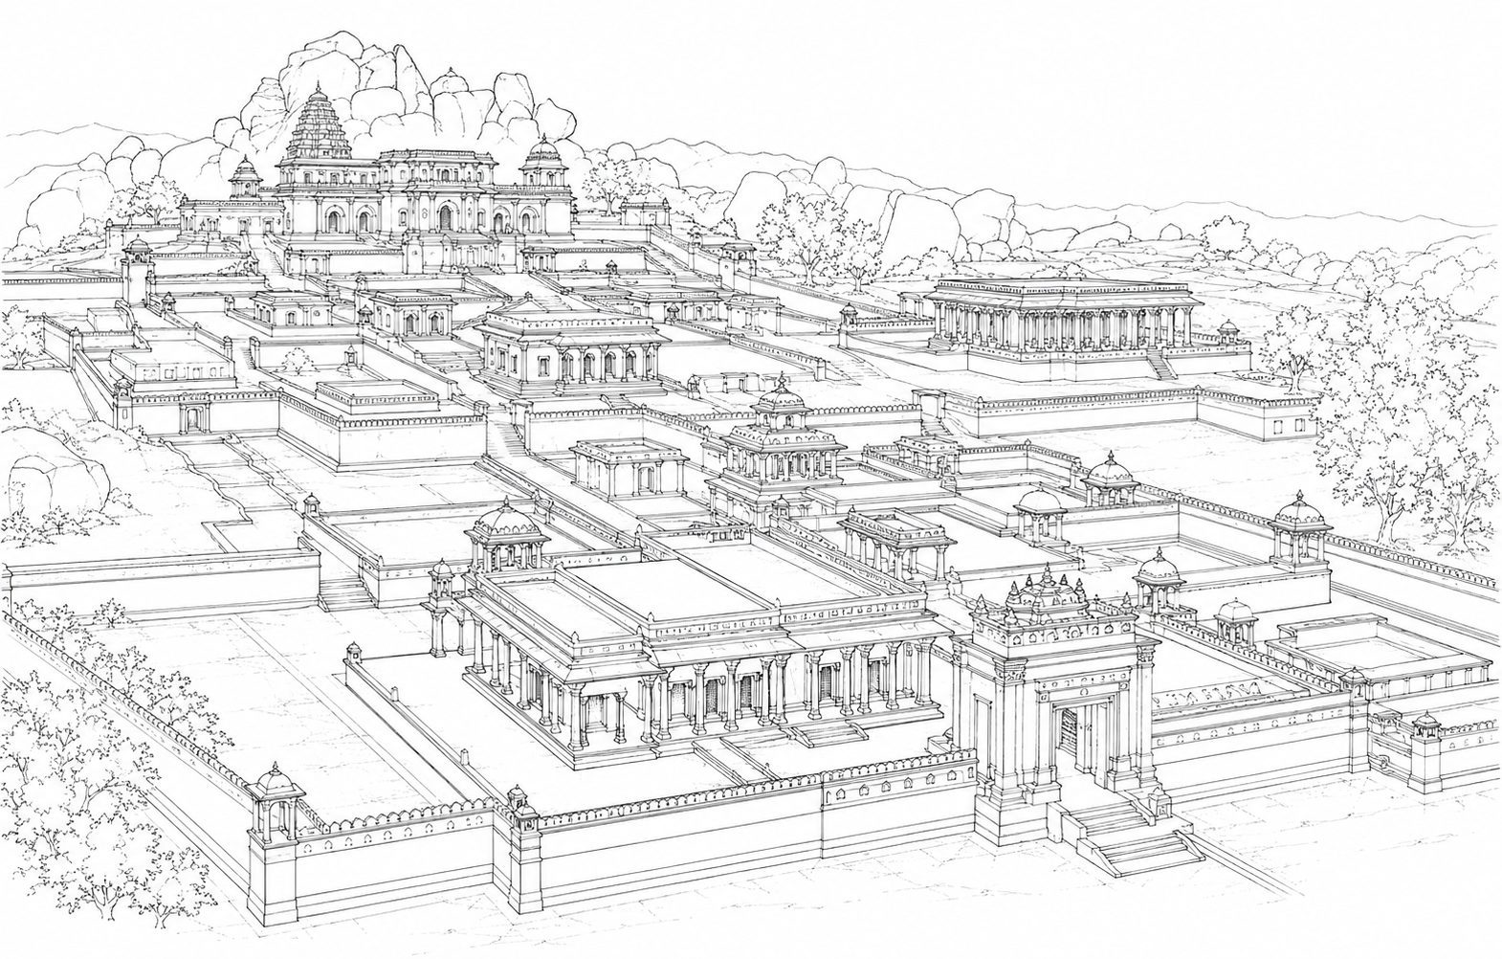
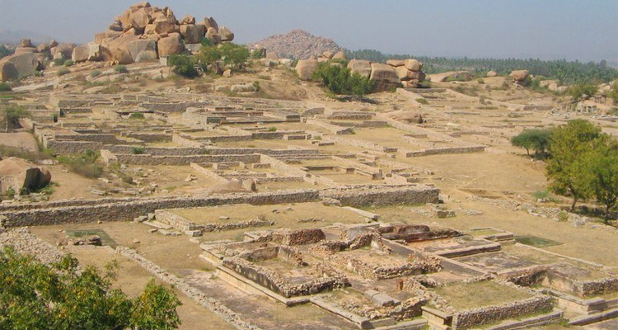
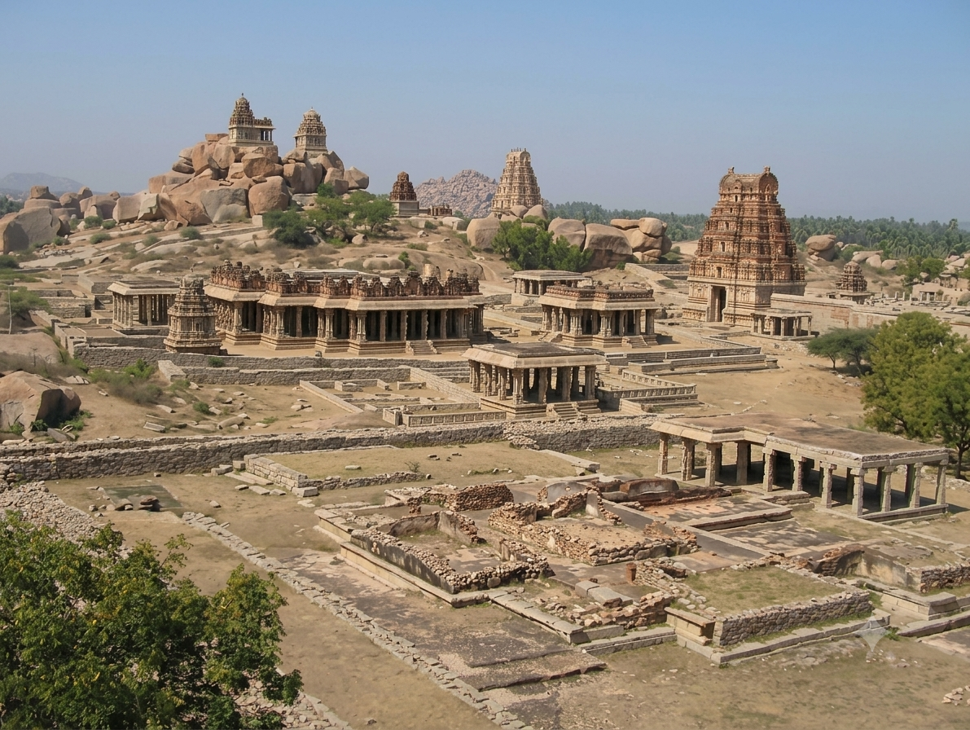
2. Mahanavami Dibba and surrounding structures:The Mahanavami Dibba is one of Hampi's most famous surviving structures. The massive stone platform itself survives, but the associated royal structures and decorative elements around it have been lost or damaged.The platform originally formed part of a larger ceremonial complex used for royal celebrations and processions.
Loss: The surviving platform represents only part of the original ceremonial setting.

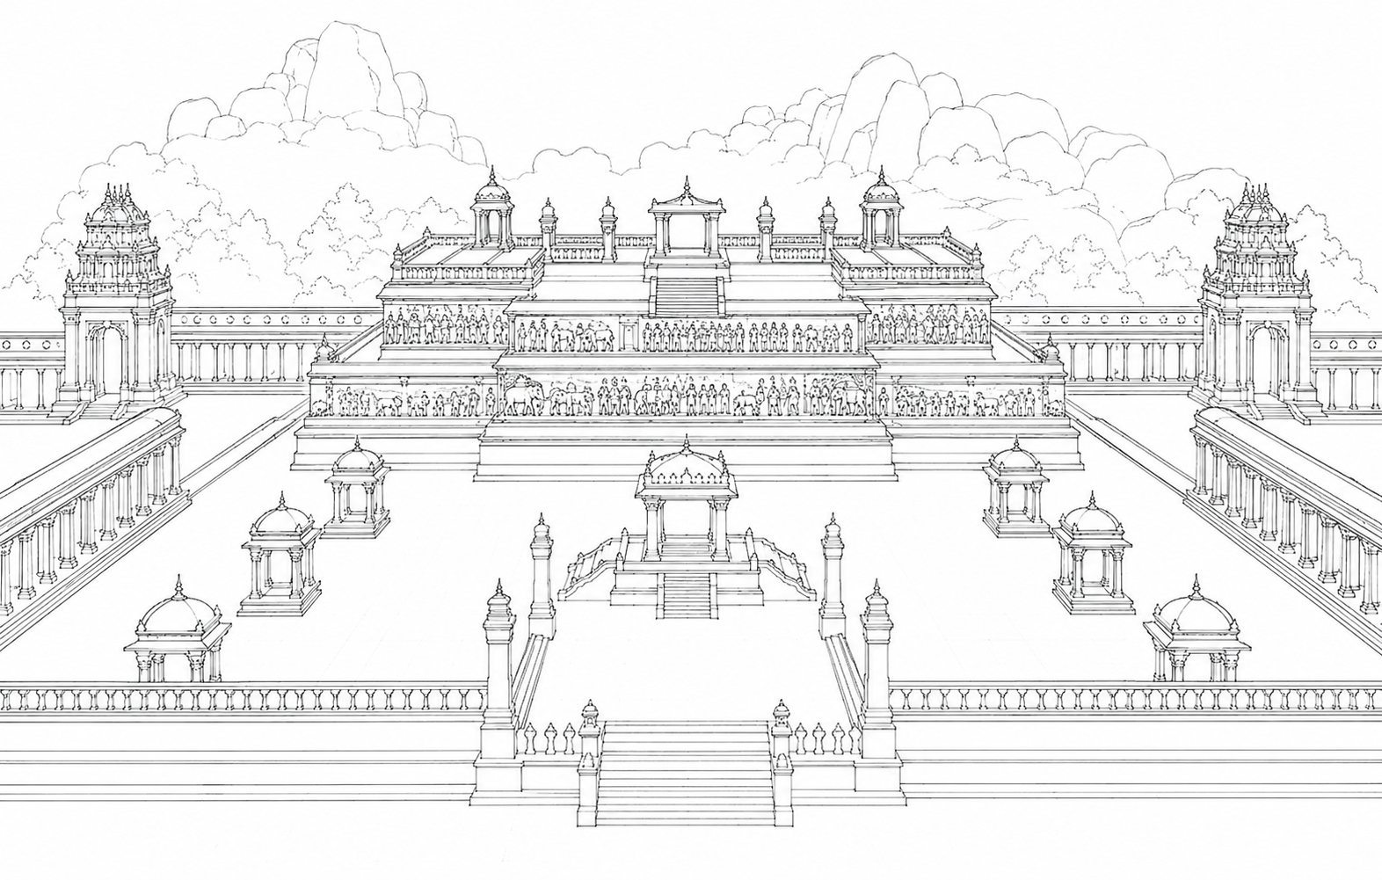

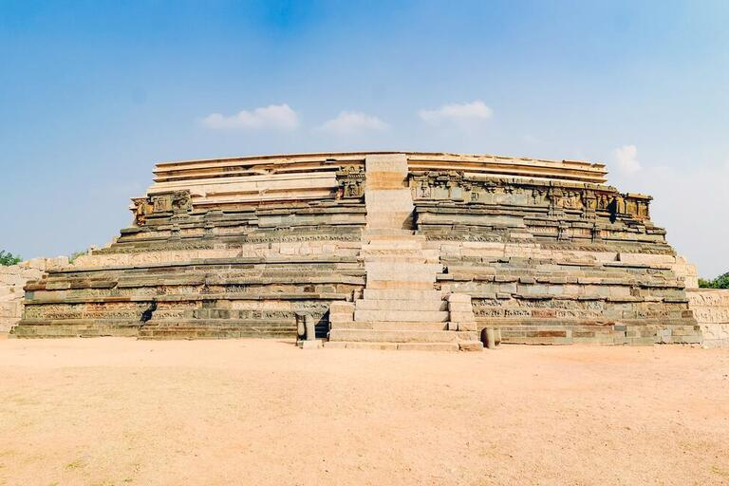
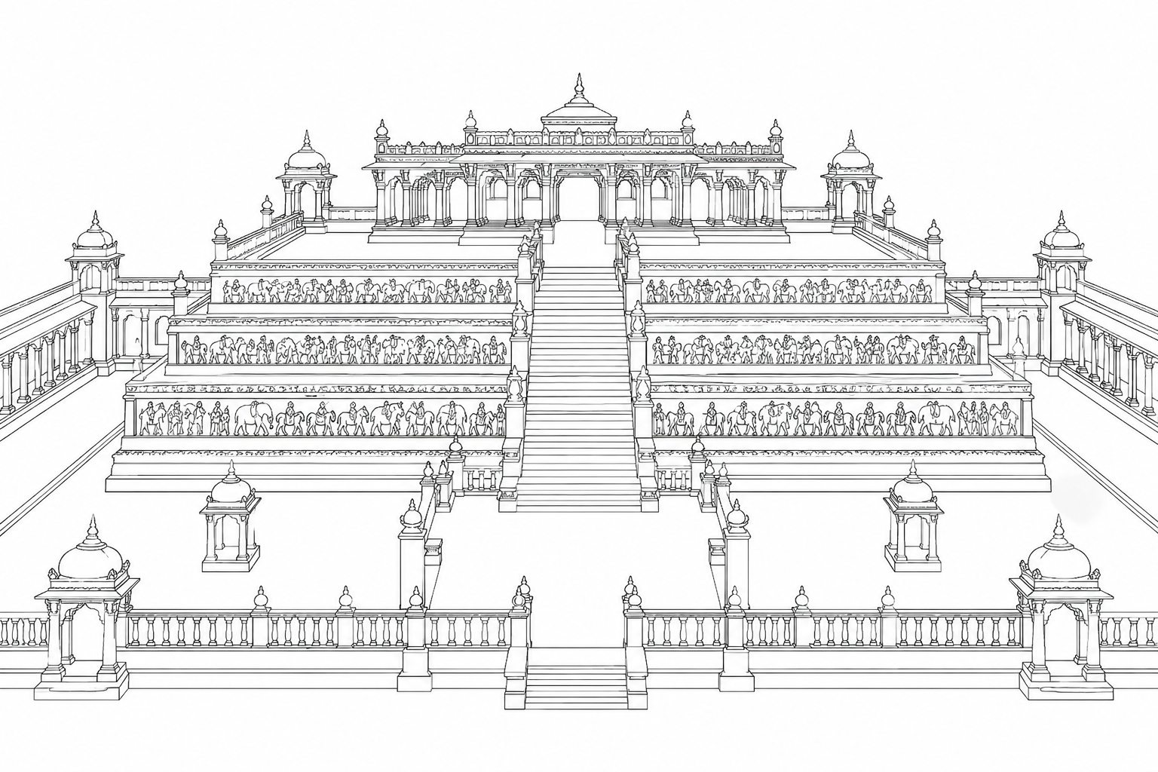
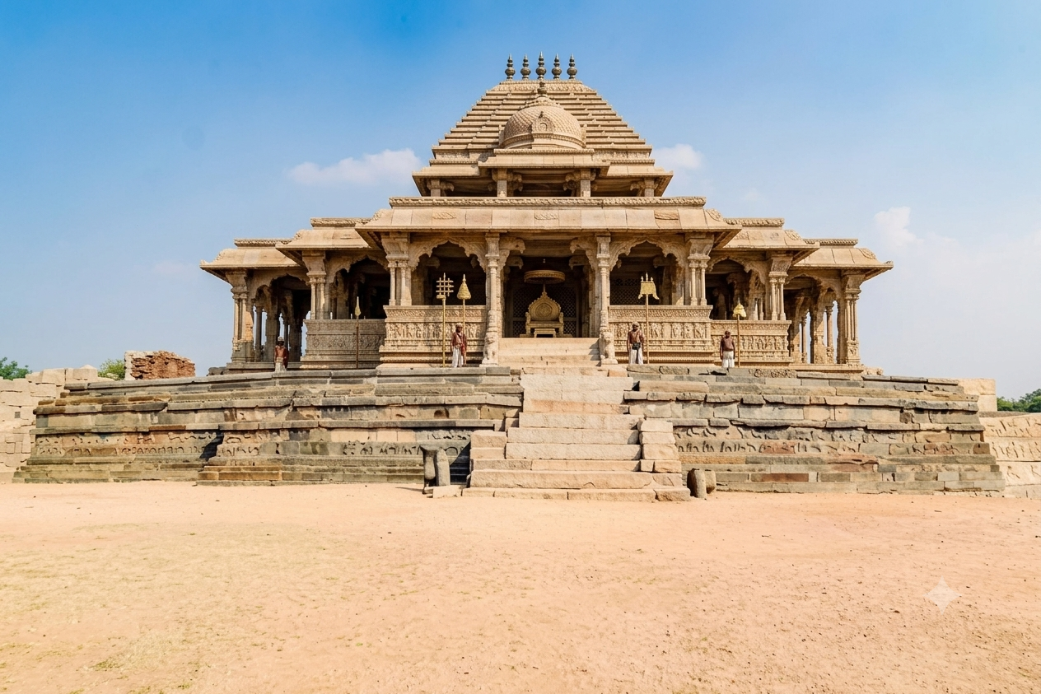
3. Vittala Temple Complex:The Vittala Temple is among the finest examples of Vijayanagara architecture. Although the central temple and famous Stone Chariot survive, several surrounding structures are damaged or incomplete.
The Archaeological Survey of India notes that the complex contains the main shrine, Devi shrine, Kalyana Mandapa, Utsava Mandapa, Hundred-Pillared Mandapa and Stone Ratha. Parts of the surrounding structures have been lost, and the temple's gopuras are now dilapidated.
Damaged/lost elements include:
- Parts of the entrance gopuras
- Portions of subsidiary mandapas
- Parts of the enclosure
- Decorative and structural stone members
- Portions of the surrounding colonnades
The ASI continues conservation work on damaged roofs, beams, capitals, pillars and flooring in the complex, demonstrating that deterioration continues beyond the original historical destruction.
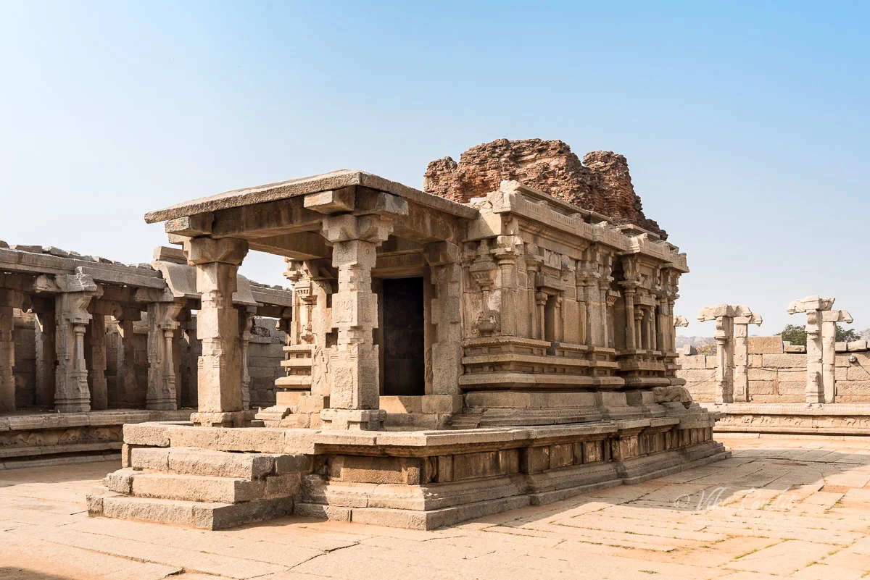
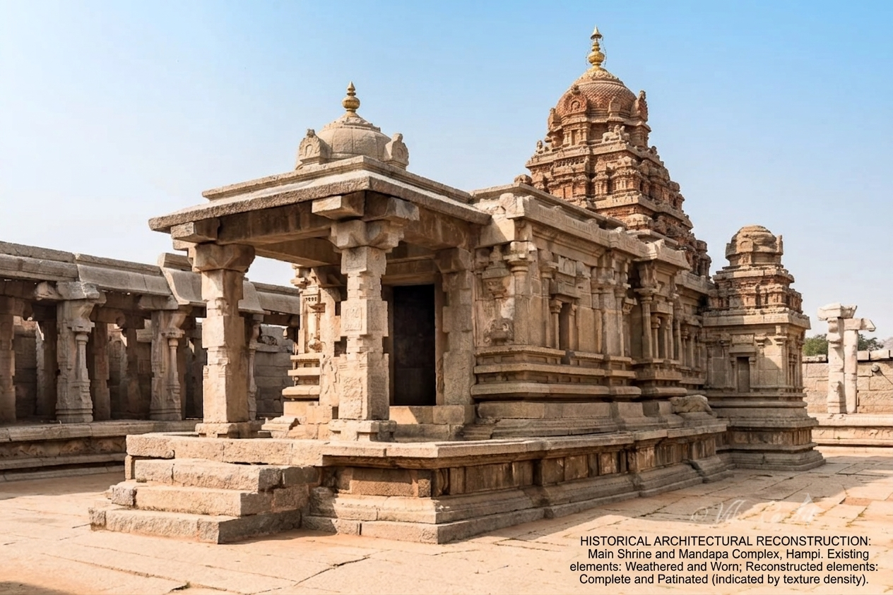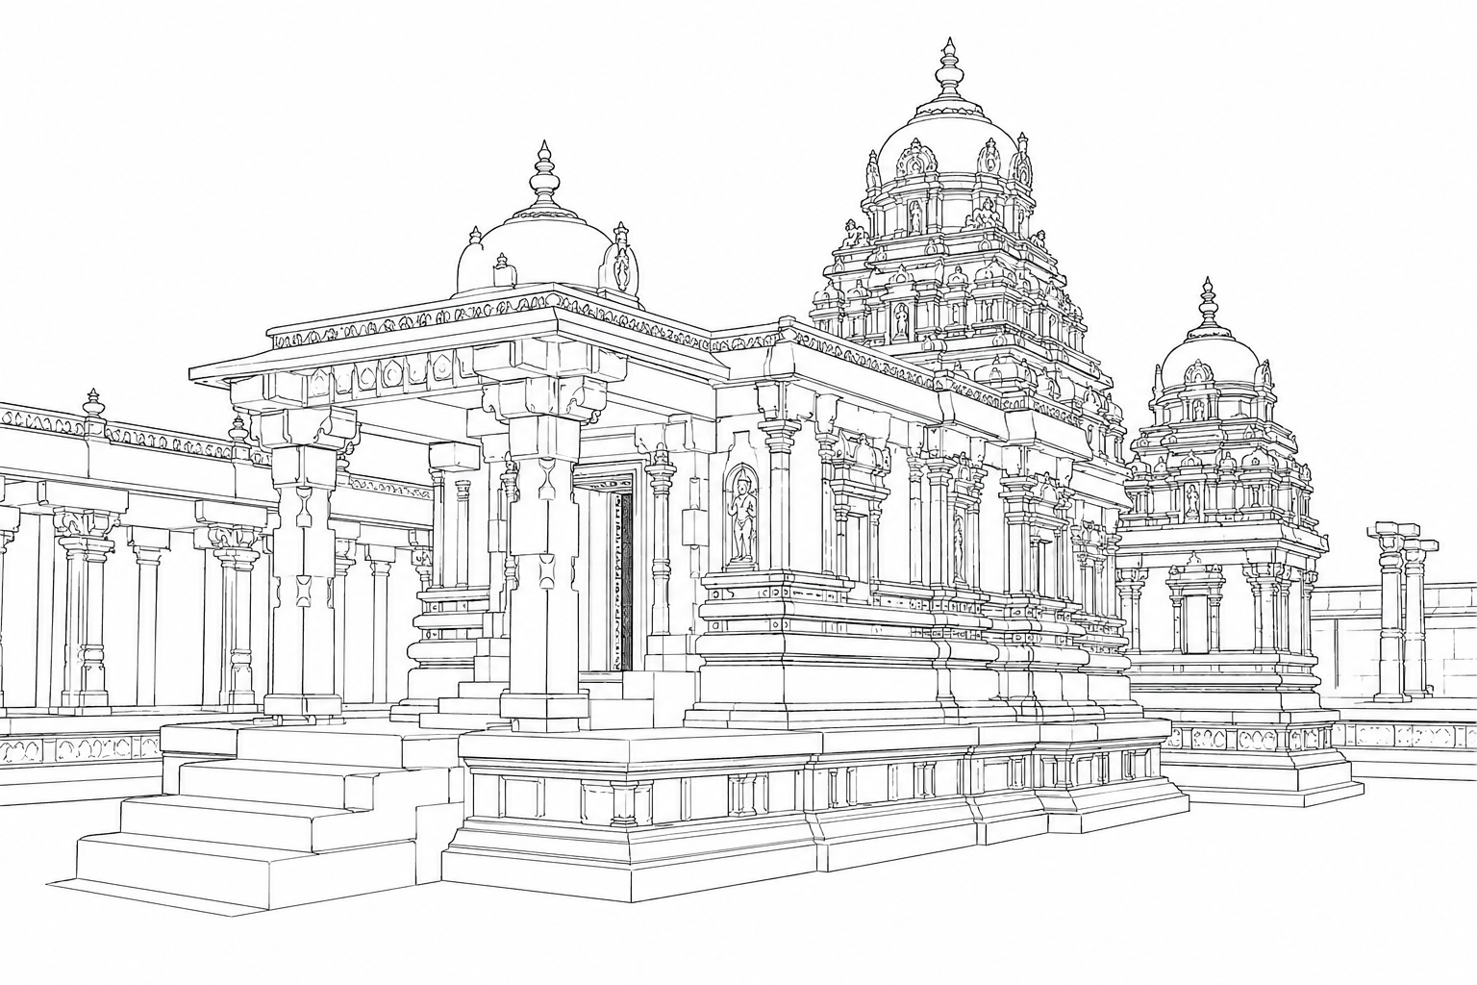
4. Achyutaraya Temple and Bazaar:The Achyutaraya (Tiruvengalanatha) Temple was surrounded by large enclosure walls and a long market street known as Achyutarayapete.The temple complex survives, but its large Kalyana Mandapas and other structures are considerably dilapidated.
Loss/damage:
- Parts of the enclosure
- Damaged mandapas
- Collapsed or weakened stone members
- Deteriorated bazaar structures
- Loss of parts of the original urban setting
This is especially important because the destruction affected not only religious buildings but also the commercial city surrounding them.
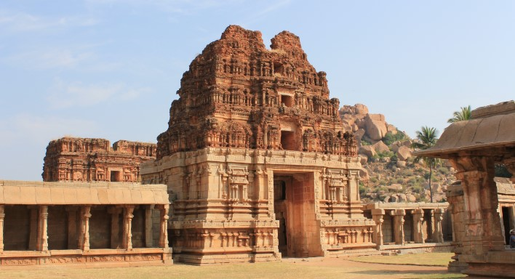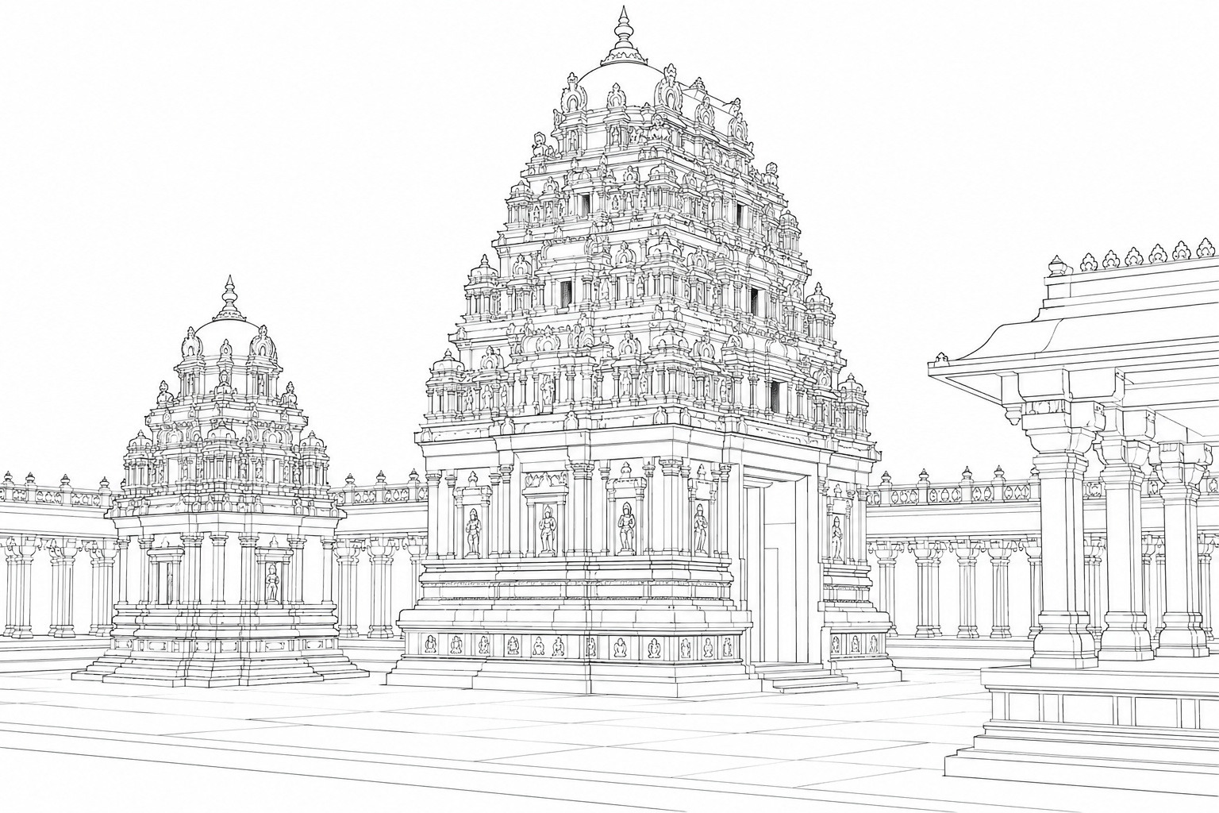
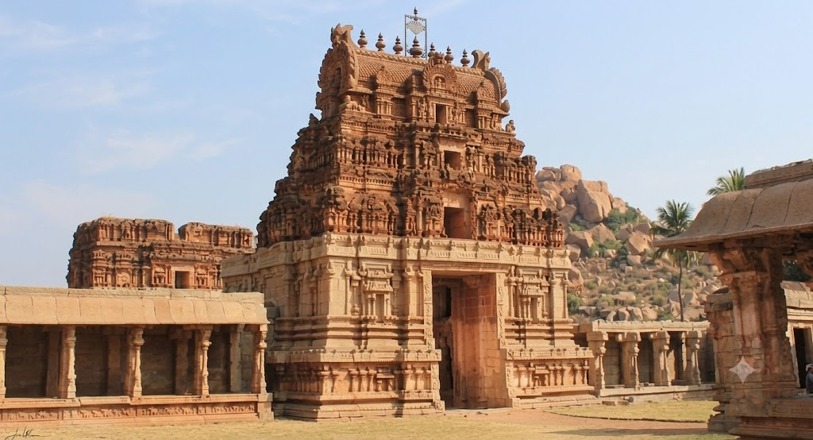
5. Krishna Temple and Bazaar:The Krishna Temple was an important religious complex associated with the reign of Krishnadevaraya.The temple survives in ruined condition, while portions of its entrance structures, bazaar and surrounding architectural elements have been lost or damaged.Current conservation proposals specifically include work on the eastern and southern entrance mahadwaras, bazaar mandapas and pushkarani (temple tank).
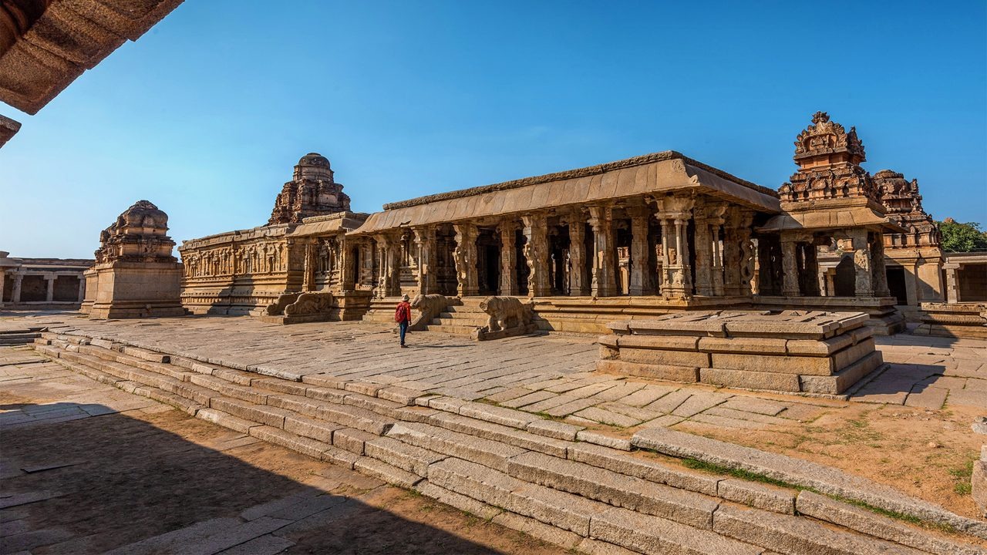
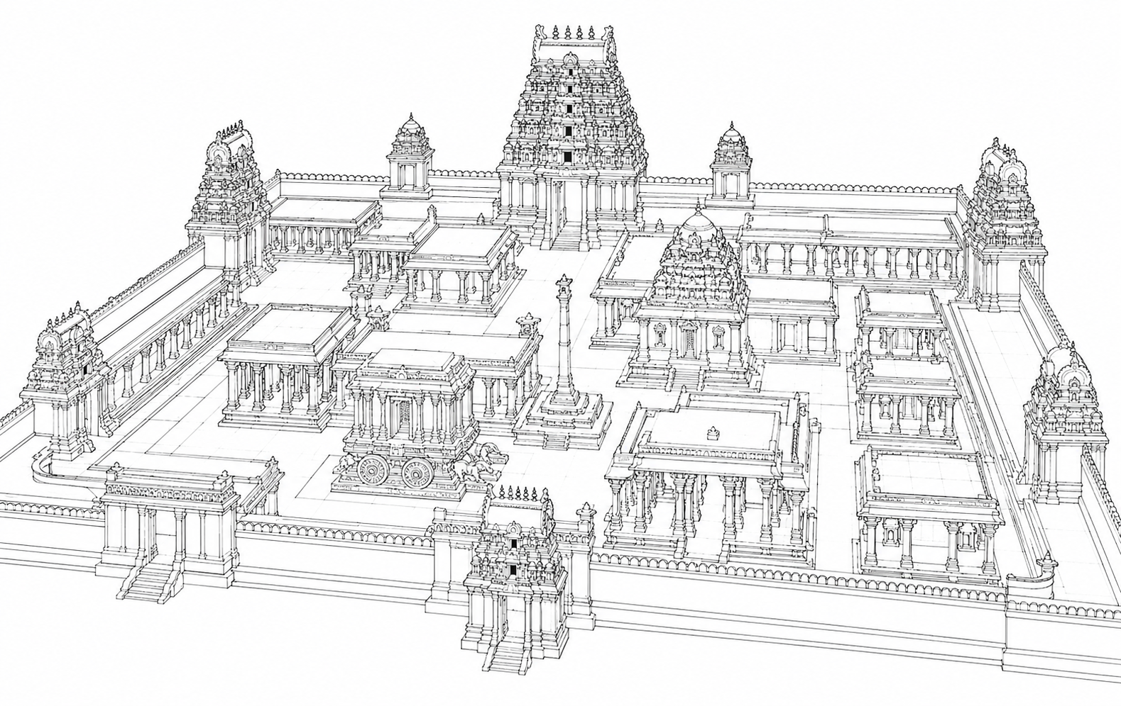
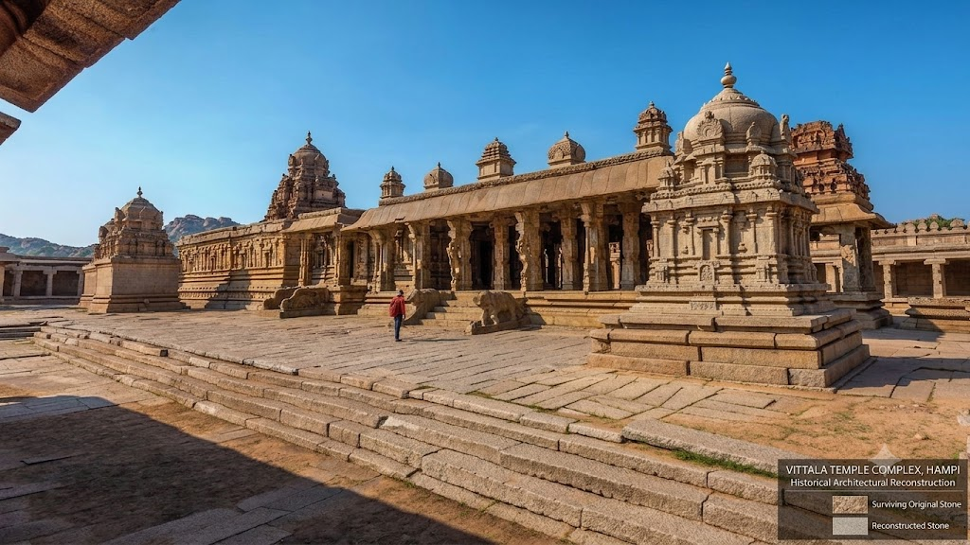
6. Hazara Rama Temple surroundings:The Hazara Rama Temple itself remains comparatively well preserved, but parts of the surrounding complex and associated structures have suffered deterioration.The temple is particularly important because its walls contain extensive narrative reliefs depicting episodes from the Ramayana and scenes associated with Vijayanagara royal life.
Loss: Damage to surrounding structures reduces the original context in which the temple functioned.
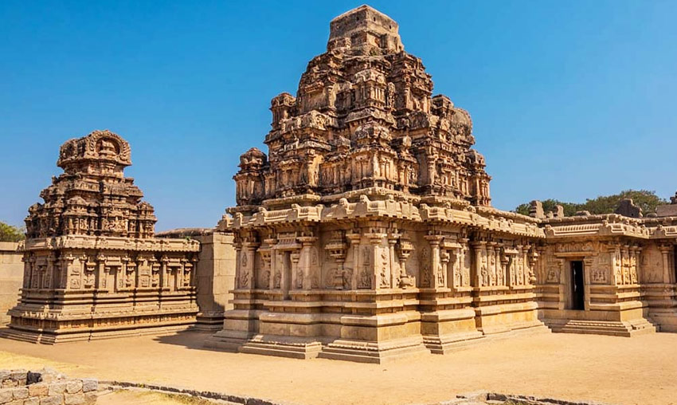
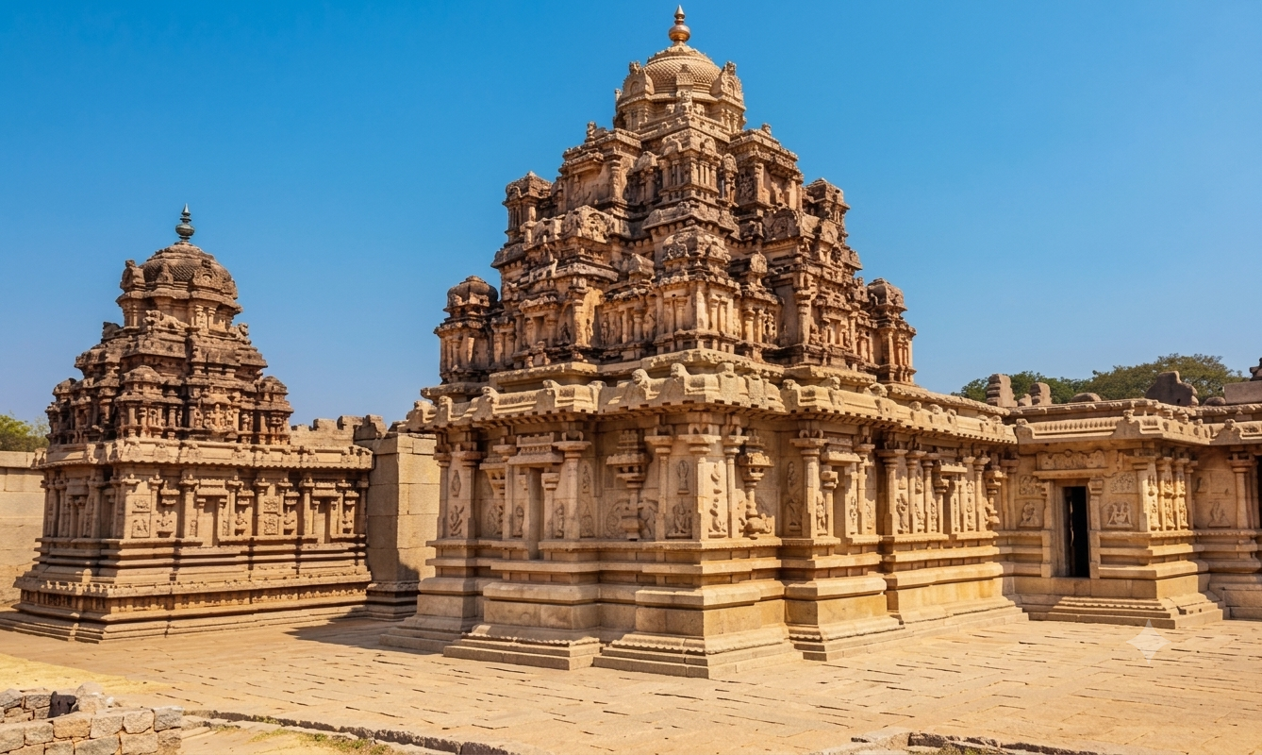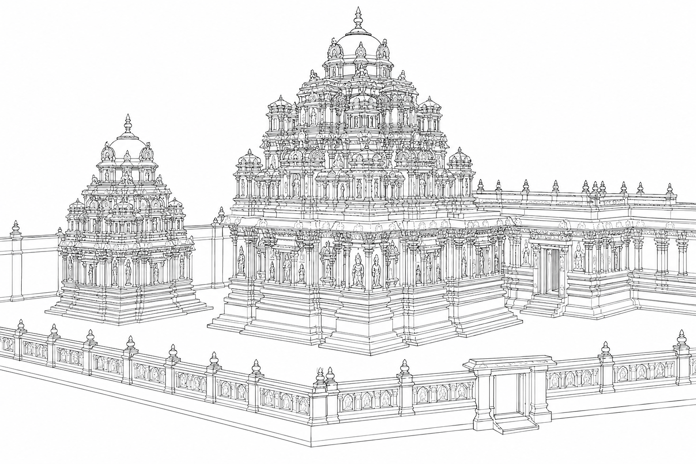
7. Zanana Enclosure:The Zanana Enclosure was a protected royal enclosure containing structures such as the Lotus Mahal and watchtowers.The enclosure walls suffered collapse and deterioration. The ASI describes the walls as massive dressed-stone constructions and has undertaken restoration of fallen portions.The northern watchtower also lost its pavilion superstructure, leaving the granite cross-beams exposed.
Damaged/lost parts:
- Sections of enclosure wall
- Gateways
- Watchtower superstructures
- Architectural decorations
- Parts of palace-related structures
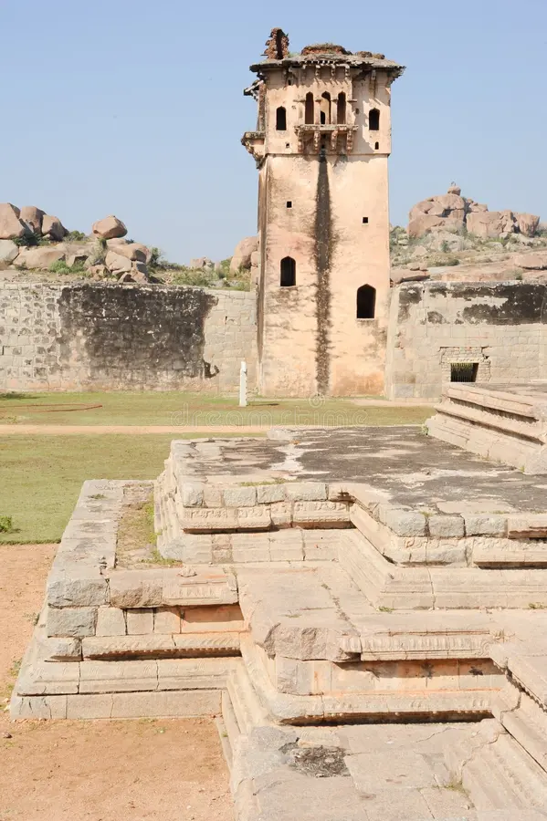
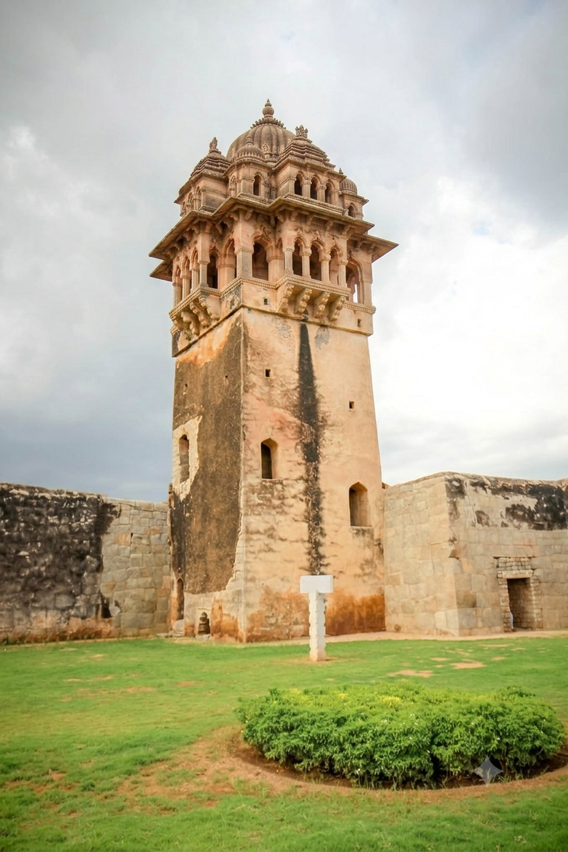
8. Lotus Mahal:The Lotus Mahal is one of the better-preserved buildings in the Zanana Enclosure, but its original appearance was more elaborate than what survives today.The ASI notes that it was originally fully decorated, painted and covered with polished plaster. Much of this original surface treatment has disappeared.
Major loss: Original plaster, paint, decorative finishes and some architectural details.
https://www.asihampicircle.in
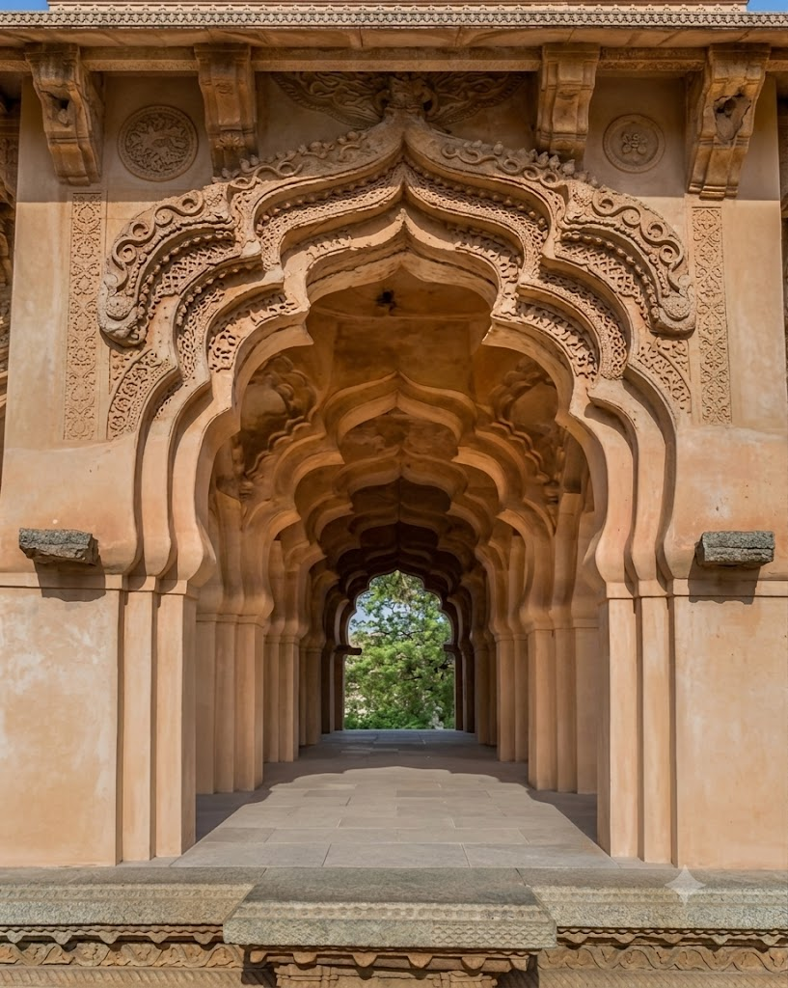
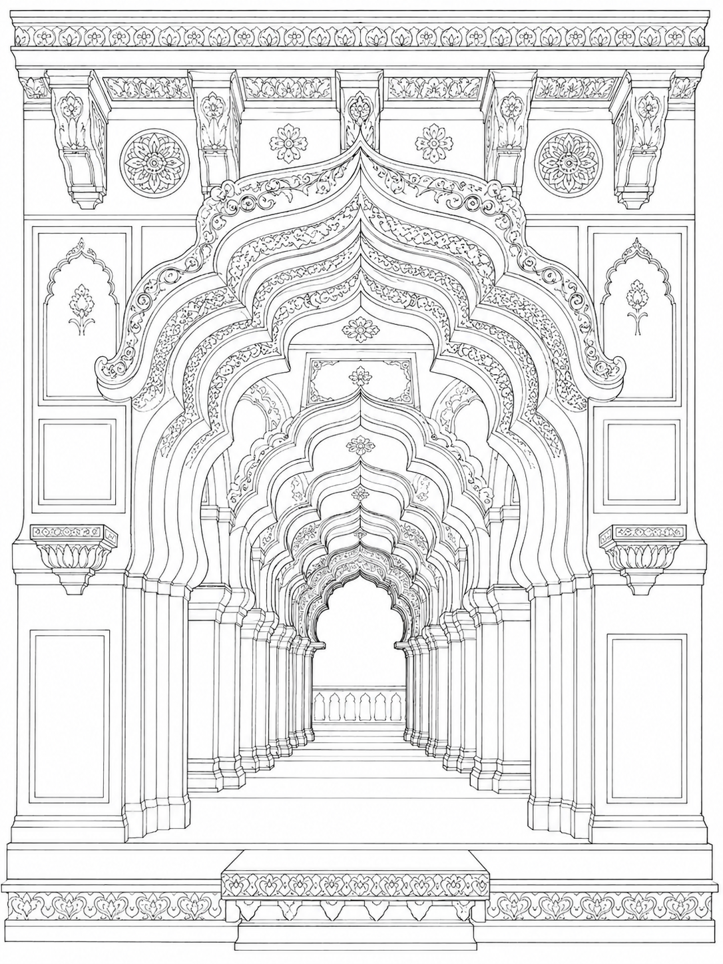
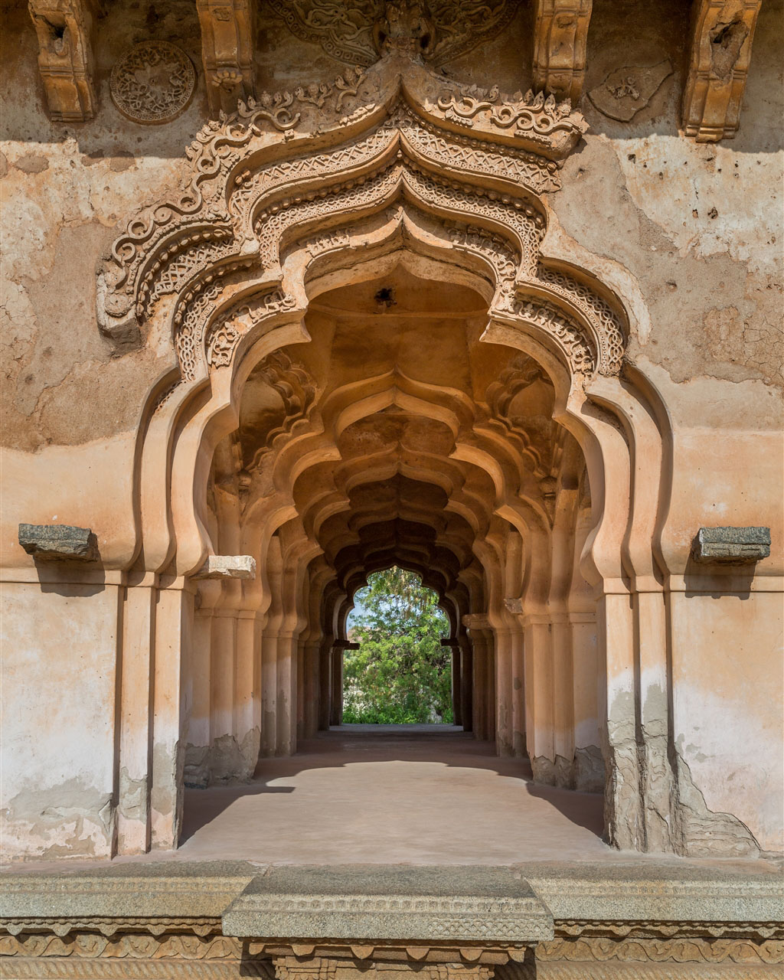
Reference videos:

1.Complete Hampi Travel Guide | Best Places To Visit And Things To Do In Hampi | Tripoto
Summary:Hampi as a historical destination: Hampi is the former capital of the Vijayanagara Empire and is recognized as a UNESCO World Heritage Site.
Major monuments: Important attractions include the Virupaksha Temple, Vittala Temple/Stone Chariot, Royal Enclosure and other Vijayanagara monuments.
Landscape: The distinctive combination of granite boulders, hills and the Tungabhadra River forms an important part of Hampi's character.
Historical atmosphere: Hampi is presented as a “lost city,” where visitors can explore the remains of a once-large and prosperous imperial capital.
Tourist exploration: The guide is aimed at helping visitors decide what places to see and what activities/experiences to include during a Hampi trip.

2.Hampi Ruins: Vijayanagara’s Tragic Tale of Betrayal and Destruction | XploreIndia Documentary
Here is the comprehensive, detailed summary in English of the documentary video "Hampi Ruins: Vijayanagara’s Tragic Tale of Betrayal and Destruction":

1. The Grandeur and Glory of Hampi [00:11]
- The Jewel of South India: Between the 14th and 16th centuries AD, Hampi served as the magnificent capital city of the Vijayanagara Empire—one of the richest, most prosperous, and most powerful empires in Indian history [00:23].
- Art and Architecture: The city stood as an unparalleled pinnacle of Indian heritage, showcasing grand temple architecture, intricate stone carvings, vibrant trade bazaars, and advanced civil engineering [00:30].
- A Tragic Contrast: Today, the silent ruins of Hampi stand as a somber witness to a tale of geopolitical jealousy, battlefield treachery, horrific bloodshed, and one of the most brutal acts of vandalism recorded in human history [00:51].

2. The Rise of the Deccan Coalition [01:41]
- The Ruler: By the mid-16th century, the Vijayanagara Empire was led by the aging yet formidable king, Rama Raya (Aliya Rama Raya), who had maintained regional dominance and expanded the kingdom’s borders despite being surrounded by rival states [02:15].
- The Bahmani Sultanates: To the north, the fragmented remnants of the Bahmani Sultanate—comprising the five Deccan Sultanates: Bijapur, Golconda, Ahmednagar, Bidar, and Berar—realized they could not defeat the Vijayanagara Empire individually [02:30].
- The Alliance of Envy: Setting aside their mutual enmities, the Sultanates (under rulers including Nizam Shah, Qutb Shah, Ali Adil Shah, and Ali Barid) forged a grand military coalition driven by collective fear, hatred, and desire to pillage South India's richest empire [02:50].

3. The Clashing Armies at the Battle of Talikota (January 1565) [03:09]
- The Staging Ground: The allied armies of the Sultanates assembled near Talikota (approximately 80 km from Bijapur and 200 km north of Vijayanagara) to march upon the capital [01:41].
- Boosting Troops' Morale: Facing an intimidating coalition force, King Rama Raya motivated his soldiers by declaring that they were warriors who did not fear the enemy [03:55].
- The Reward of Valor: To inspire his men, Rama Raya placed massive mounds of gold coins and precious jewels on display, announcing that soldiers displaying exceptional battlefield courage would be lavishly rewarded and granted royal honors [04:07].
- Initial Dominance: Reignited with vigor, the Vijayanagara army launched a fierce initial offensive that overwhelmed and forced large sections of the Bahmani frontline into retreat [04:29].

4. Treachery, Betrayal, and the Fall of Rama Raya [04:50]
- The Fatal Betrayal: At the decisive turning point of the battle, deep-seated conspiracy unfolded. A large contingent of Muslim soldiers within the Vijayanagara ranks—under the influence of Rama Raya's trusted commanders, the Gilani brothers—refused to fight against the Sultanates, deserted their posts, and turned their weapons against Vijayanagara [05:10].
- The Artillery Ambush: Amidst the sudden chaos and scattered formations, an artillery officer named Rumi Khan fired heavy cannon barrages directly at the Vijayanagara lines, causing massive destruction [05:38].
- Capture and Execution: Rumi Khan charged on his war elephant, killing the king's bodyguards. The 90-year-old Rama Raya was wounded and thrown from his palanquin [05:57]. Captured and brought before Sultan Hussein Nizam Shah, Rama Raya maintained stoic silence, touching his forehead to signify submission to fate [06:29]. Hussein Nizam Shah personally beheaded the emperor, affixing his severed head onto a spear tip to display to the retreating troops [06:46].
- The Massacre: The Vijayanagara ranks collapsed into total disarray, leaving nearly 20 miles of battlefield carpeted with casualties [07:03].

5. The Relentless Five-Month Destruction of Hampi [07:29]
- Panic in the Capital: When the horrifying news reached Hampi, royal guards and citizens hastily buried whatever gold and jewels they could carry before fleeing into the surrounding hills [07:37].
- First Wave of Plunder: Opportunistic bandits, robbers, and jungle tribes initially raided the undefended outskirts of the city [07:47].
- The Five-Month Rampage: On the third day, the main allied armies entered Hampi. For five consecutive months, the invading forces executed an unrelenting, systematic campaign of arson, looting, and cultural destruction [07:56]:
  - Massive monuments, palaces, and council chambers were demolished using crowbars, heavy iron rods, and fire [08:51].
  - Iconic structures, including the famous Ugra Narasimha statue and the monumental complexes surrounding the Vijaya Vittala Temple, had their limbs, pillars, and shrines smashed into rubble [08:15].
  - The royal palaces and living quarters were burned and pulverized so thoroughly that today only stone bases and lonely pillars remain [08:39].
The once-thriving metropolis, which rivaled Rome and Beijing in wealth and grandeur, was completely eradicated and left as an open-air graveyard of stone and memories [09:09].

3.Hampi’s Fall: How a Mighty Empire Collapsed in 6 Months
Here is the comprehensive summary of the documentary video "Hampi’s Fall: How a Mighty Empire Collapsed in 6 Months" by Bharat Varsh project:

1. Ancient Origins and Sacred Mythological Roots [00:00]
- Pre-Vijayanagara Antiquity: Long before the rise of the Vijayanagara Empire, Hampi was known as Pampa Devi Kshetra in sacred Hindu texts like the Ramayana and the Puranas [00:19].
- The Legend of Pampa: The name originates from Goddess Parvati (known as Pampa), who performed intense penance on Hemakuta Hill to win the hand of Lord Shiva (Pampapati) [01:36]. Over time, Sanskrit Pampa evolved into the Kannada name Hampe / Hampi [01:50].
- Ramayana Connection: The region is immortalized as Kishkindha, where Lord Rama and Lakshmana met Hanuman, Sugriva, and the Vanara army during their search for Sita [02:00].
- Early Historical Inscriptions: Rock edicts of Emperor Ashoka (3rd century BCE) [02:18], along with inscriptions from the Badami Chalukyas, Kalyana Chalukyas, and the Hoysala Empire [02:46], confirm the site's enduring religious and administrative importance.

2. The Rise of the Vijayanagara Empire (1336 CE) [03:44]
- Invasions from the North: In the 14th century, forces of the Delhi Sultanate (Alauddin Khalji and Muhammad bin Tughlaq) devastated regional powers like the Hoysalas and the Kampili kingdom [03:52].
- Founding of the Empire: In 1336 CE, Harihara I and Bukka I, guided and supported by sage Vidyaranya, established a new capital named Vidyanagara (later Vijayanagara / Hampi) [05:06].
- Global Prominence by 1500 CE: By 1500 CE, Vijayanagara had become the second-largest city in the medieval world (after Beijing) and arguably the wealthiest metropolis in India [01:08], attracting trade missions and travelers from Persia, Portugal, and the Deccan [05:37].
- Architecture and Urban Planning: Foreign chroniclers like Domingo Paes (c. 1520) compared its grandeur to Rome [06:47]. The city was fortified with seven concentric rings of defensive walls, vibrant markets, and advanced civil structures such as the Lotus Mahal, Elephant Stables, and riverside temple complexes [06:19].

3. The Catastrophic Battle of Talikota (1565 CE) [07:09]
- The Coalition: The allied armies of the Deccan Sultanates marched south to confront Vijayanagara [07:09].
- Betrayal on the Brink of Victory: Vijayanagara forces led by King Rama Raya were initially close to victory [07:36]. However, at a crucial turning point, two key generals defected to the enemy camp [07:43].
- Execution of Rama Raya: King Rama Raya was captured and beheaded on the battlefield, causing the imperial army to fracture into chaotic retreat [07:54].

4. Six Months of Relentless Destruction [08:04]
- Systematic Destruction: Following the military collapse, the victorious Sultanate armies spent six continuous months looting, burning, and smashing the metropolis with fire, swords, axes, and crowbars [08:12].
- Robert Sewell’s Account: Quoting colonial historian Robert Sewell (A Forgotten Empire), the video highlights that rarely in world history has such total devastation fallen so suddenly upon a bustling, wealthy capital [08:22].
- Complete Desolation: Visiting shortly after 1565, Italian traveler Cesare Federici described the once-crowded capital as entirely empty, desolate, and reclaimed by wilderness [08:45].

5. Historical Legacy and Civilizational Message [09:01]
- Civilizational Fragility: Citing historian Will Durant, the documentary emphasizes that peace, liberty, and refined culture can swiftly be brought down by war and violence if not vigilantly protected [09:20].
- Enduring Heritage: The video concludes with a call to preserve, honor, and remember Hampi not merely as tragic ruins, but as an enduring symbol of cultural resilience and a precursor to later resistance movements such as Chhatrapati Shivaji Maharaj's Hindavi Swarajya [10:19].

Climate of Hampi
Hampi, located in Vijayanagara district of Karnataka, has a hot and generally dry tropical climate. Its landscape of rocky hills and granite boulders, along with relatively low rainfall compared with wetter parts of Karnataka, gives the region a semi-arid character.

1. Summer — March to May
- Summers are very hot and dry.
- Temperatures commonly rise to around 38–40°C, particularly in April and May.
- The rocky landscape absorbs and radiates considerable heat, making afternoons especially hot.
- Vegetation becomes relatively dry during this period.

2. Monsoon — June to September
- Hampi receives rainfall mainly during the southwest monsoon.
- The government tourism planning report indicates that about 67% of annual rainfall occurs during June–September.
- Humidity increases during the monsoon, and the Tungabhadra River and surrounding vegetation become more prominent.
- Rain can make some outdoor routes and monument areas difficult to access.

3. Winter — October to February
- Winter is the cooler and more comfortable season.
- Temperatures are generally around 15–30°C, although daytime temperatures can still be warm.
- October and November can have greener surroundings after the monsoon, while December–February are relatively dry and pleasant.

Special Food of Hampi

Hampi’s food culture is strongly influenced by North Karnataka and traditional South Indian cuisine. Because Hampi is a historic tourist region, you can find both traditional local dishes and simple South Indian meals.

Traditional & popular foods
- Jolada Rotti (Jowar Bhakri)
A flatbread made from jowar (sorghum) flour. It is commonly served with vegetable curries, chutney, or dal.
- Ennegai / Badanekai Ennegai
Small brinjals stuffed with a spicy mixture of ground peanuts, coconut, sesame and spices, then cooked in a thick gravy. It is a popular North Karnataka dish.
- Yennegai with Jowar Rotti
This combination is particularly characteristic of North Karnataka cuisine and makes a good example to include in a Hampi cultural project.
- Bisi Bele Bath
A hot, mildly spicy rice-and-lentil dish cooked with vegetables and spices. It is widely eaten in Karnataka.
- Ragi Mudde
A traditional Karnataka food made from ragi (finger millet) flour. It is generally eaten with sambar, dal or vegetable-based curries.

Stay near Hampi
(source : google maps)
Hotel / Resort Name | Type & Highlights | Approx. Nightly Price | Rating
Wanderlust Hampi | Popular among travelers, highly rated, peaceful ambiance | ~₹2,580 | 4.6 / 5
Hampi Delmont Resort | Comfortable resort, great for families and groups | ~₹2,860 | 4.5 / 5
3Season Resort Hampi | Well-equipped resort close to historical attractions | ~₹3,450 | 4.3 / 5
Waterfall Guesthouse | Budget-friendly guesthouse, economical option | ~₹1,680 | 4.2 / 5
Banana Tree Home Stay | Cozy homestay offering a local, traditional feel | ~₹2,100 | 3.7 / 5

Group of Monuments at Hampi

Karnataka
Inscribed as a UNESCO World Heritage Site in 1986, the Group of Monuments at Hampi in Karnataka represents the magnificent capital of the Vijayanagar Empire, which flourished between the 14th and 16th centuries. Known for its grand Dravidian temples, royal palaces, and bazaars, Hampi exemplifies the artistic and architectural excellence of the last great Hindu kingdom. Despite its destruction and abandonment after the 1565 conquest by the Deccan Muslim confederacy, the ruins remain a testament to the city’s historical, cultural, and spiritual significance, drawing scholars and visitors from around the world.
FACT CHECK BY : https://culture.gov.in/
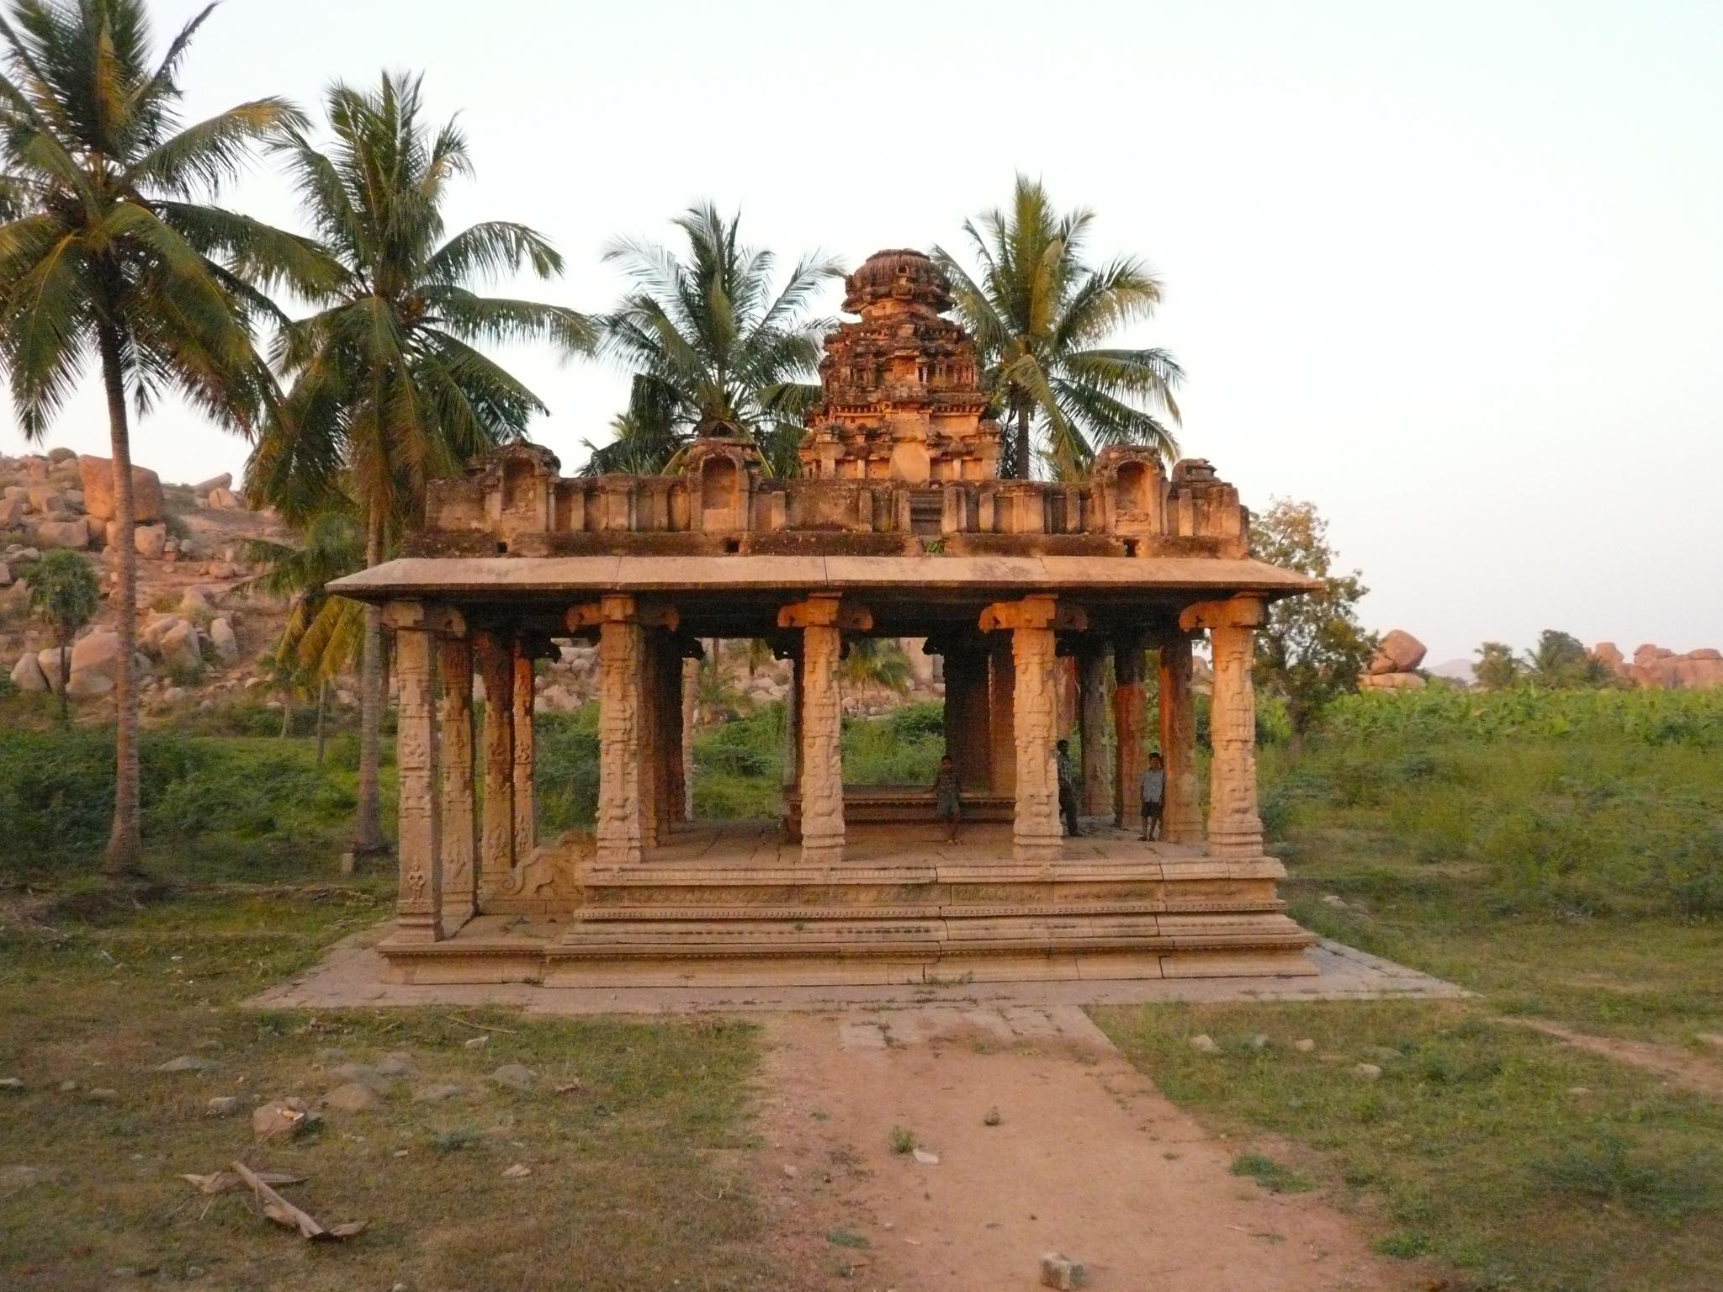

Top Places at Hampi By Karnataka government website :

Hemakuta Hill
Hemakuta Hill stands as one of the most scenic spots in Hampi. A cluster of small ancient temples from the early Vijayanagara period defines the hill.
From the top, visitors can enjoy beautiful views of the surrounding ruins and landscape. The area becomes especially popular during sunrise and sunset, when golden light falls on the temples and boulders. Its peaceful atmosphere draws travelers who seek quiet moments away from the crowds.
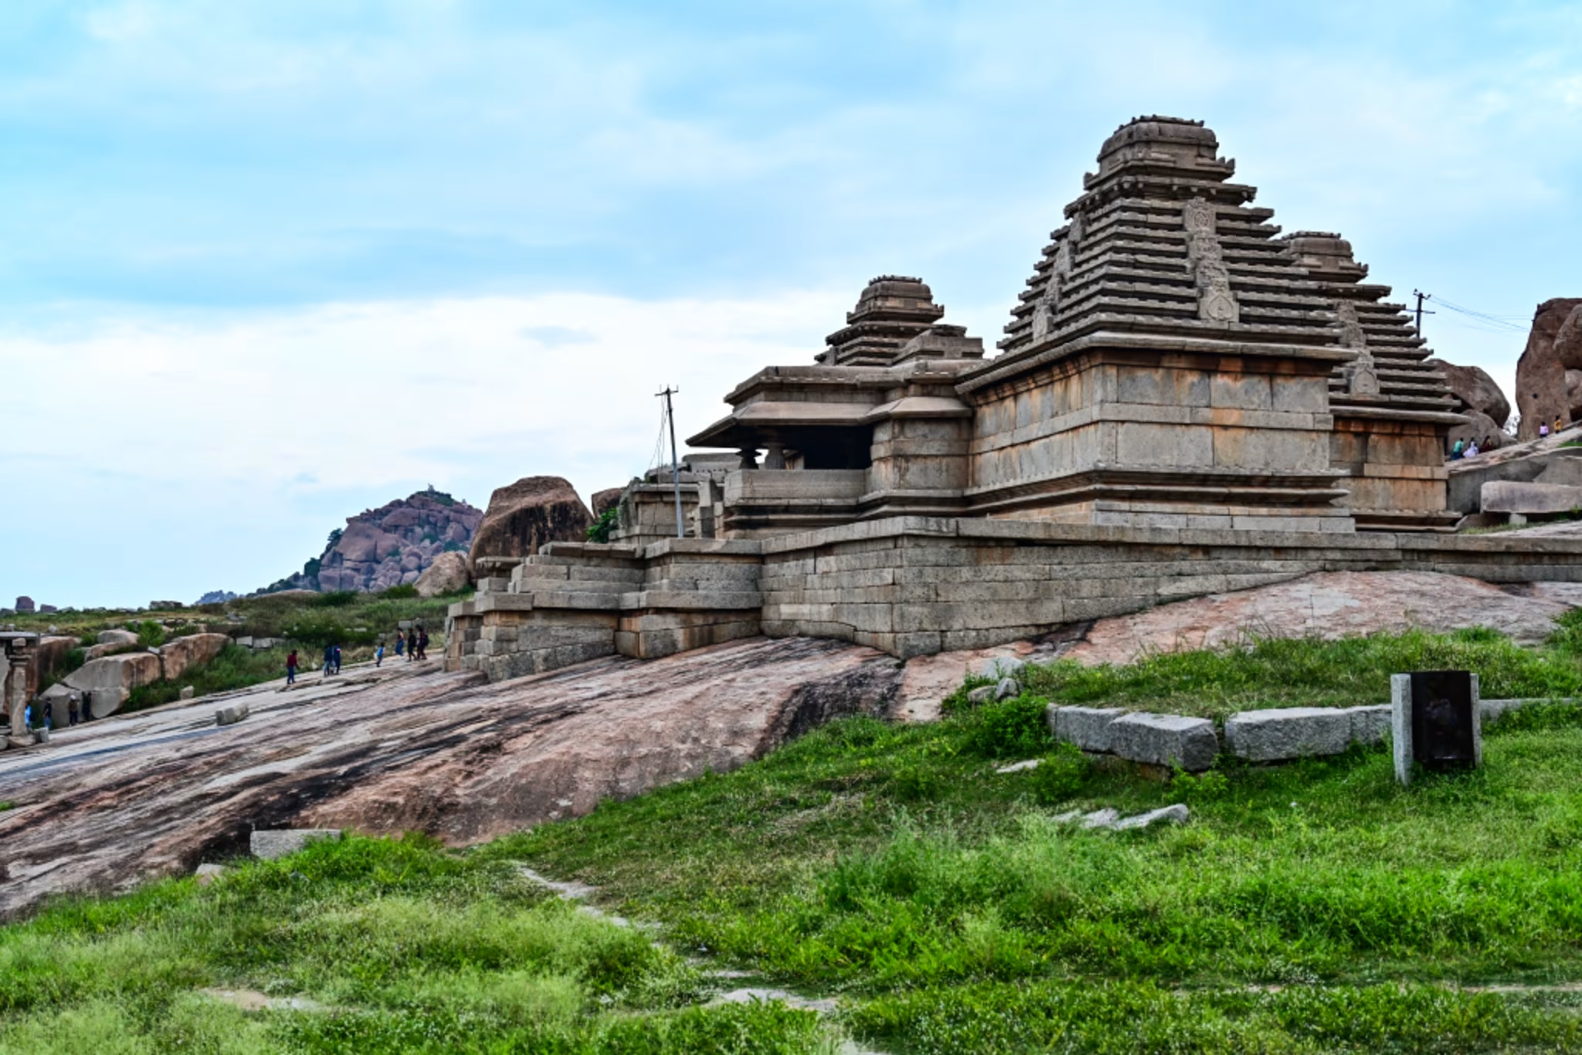

Ugra Narasimha Statue
The Ugra Narasimha is one of the most striking sculptures in Hampi. This massive statue represents Lord Narasimha, an avatar of Lord Vishnu. Carved from a single granite rock, the statue stands about 6.7 meters tall. People consider it the largest monolithic sculpture in Hampi. The fierce expression of the deity and the intricate carvings make it a powerful representation of Vijayanagara artistry.
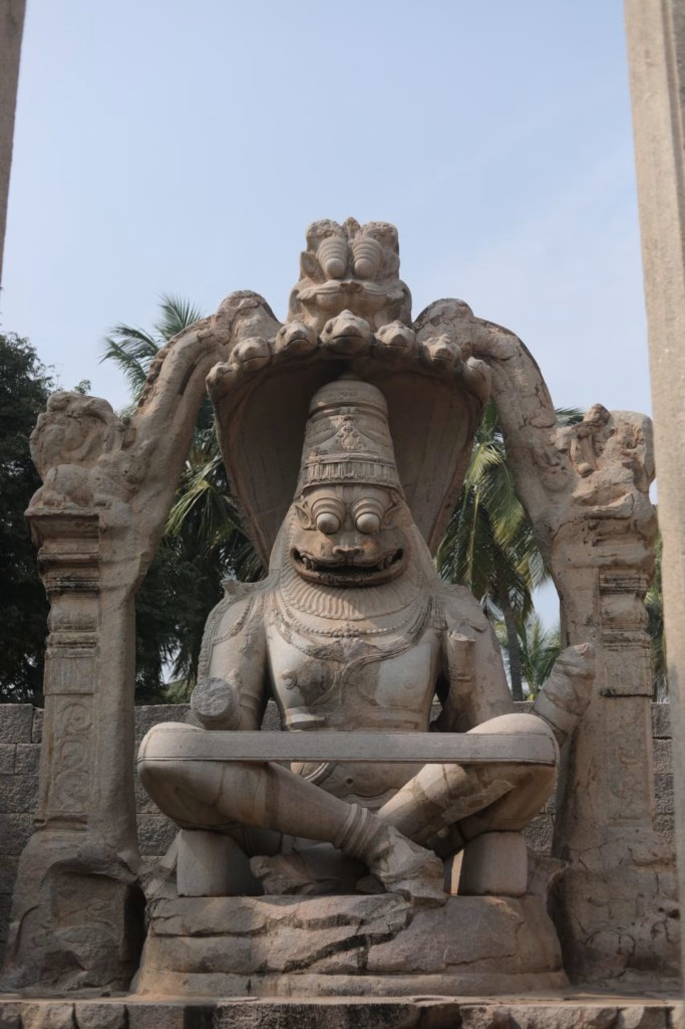

Elephant Stables
The Elephant Stables is another impressive structure from the Vijayanagara period. The empire used this long building to house its royal elephants. The structure consists of eleven large domed chambers connected by arched corridors. The architecture shows a unique blend of Hindu and Indo-Islamic styles. Each dome has a slightly different design, which adds to the beauty of the monument.
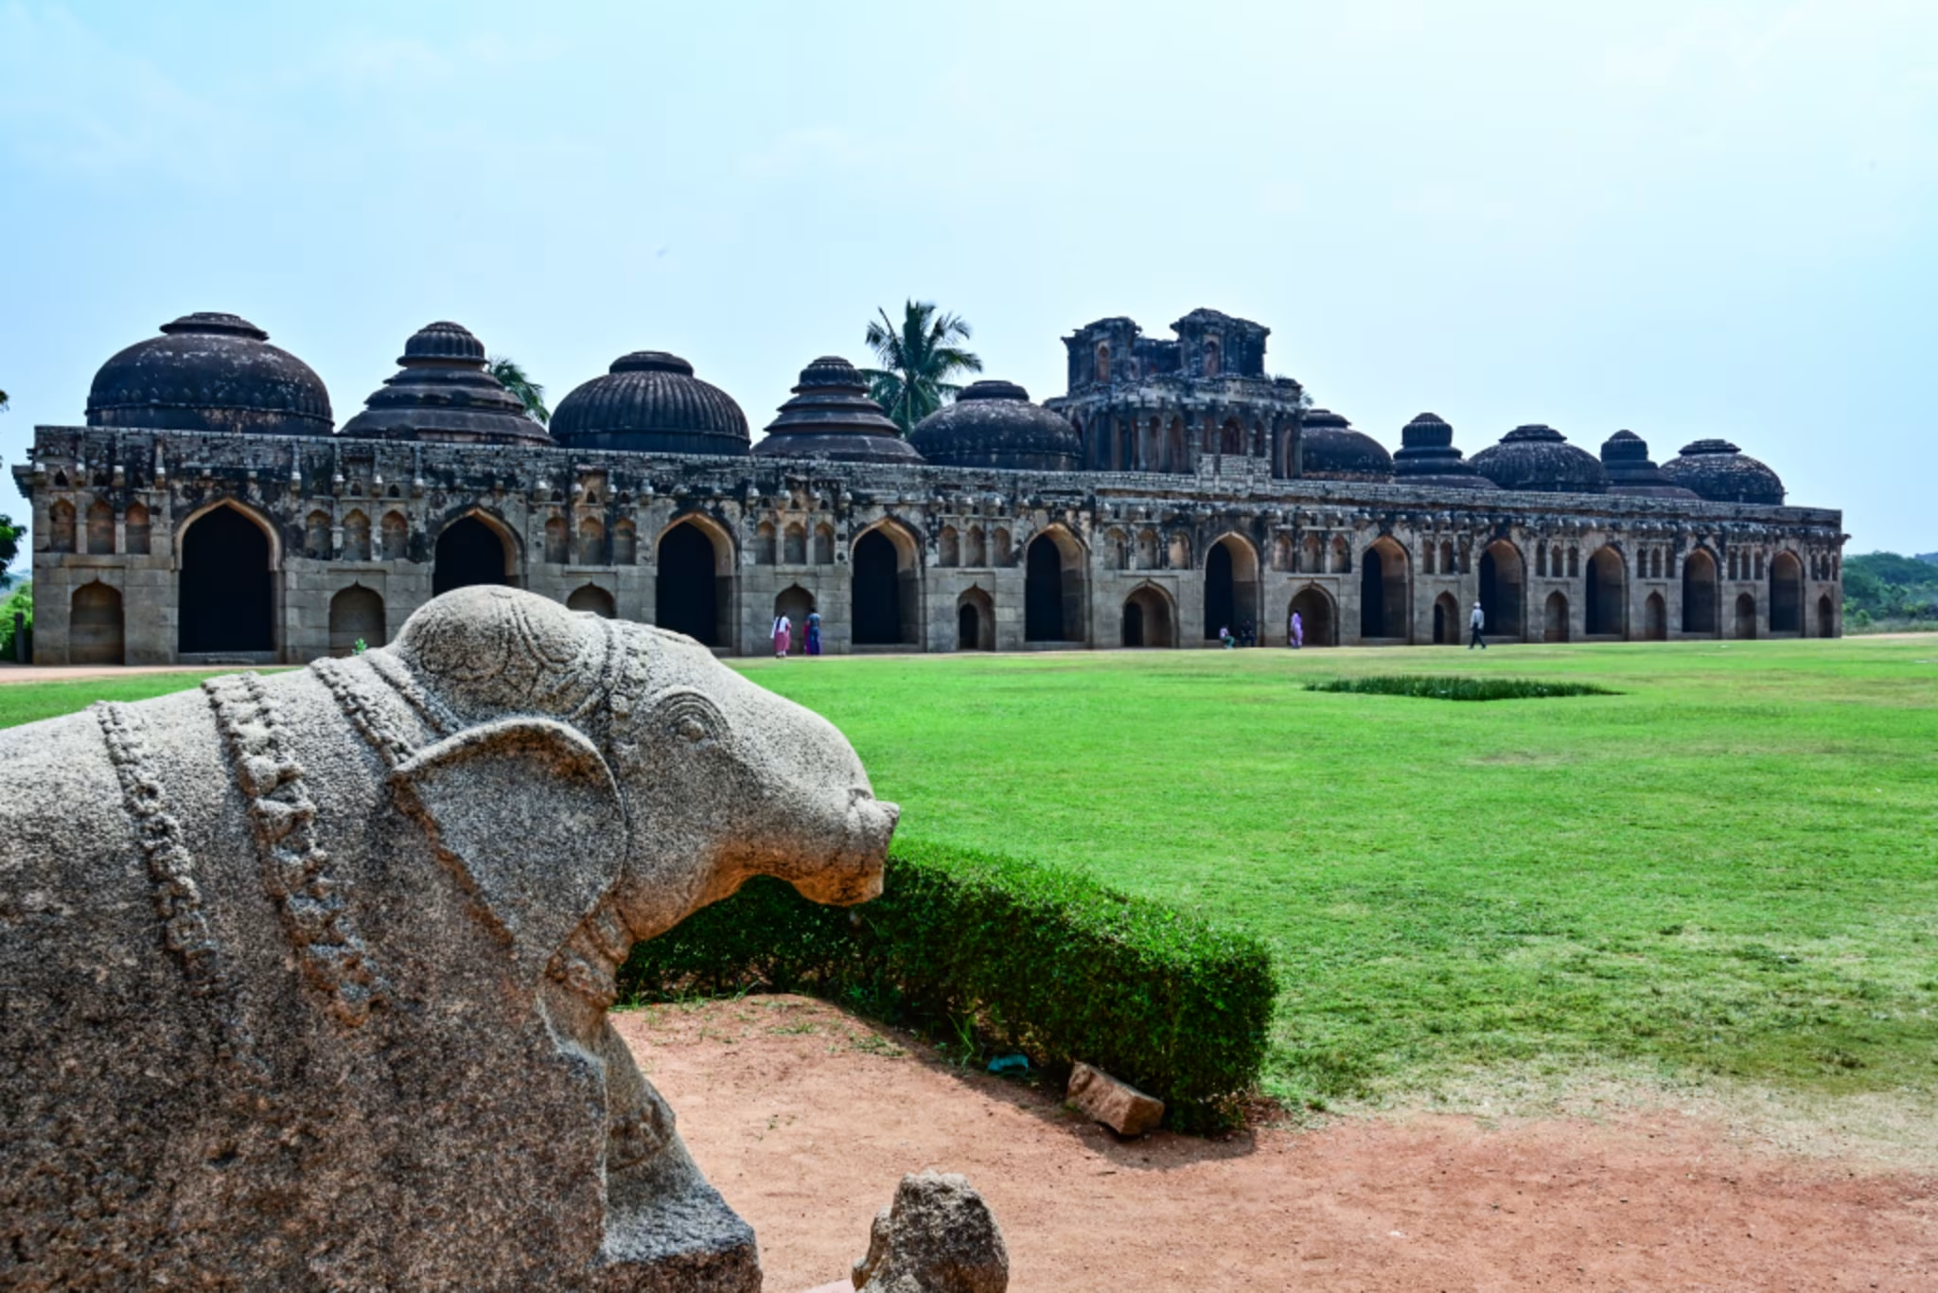

Queen’s Bath
The Queen’s Bath used to be a private bathing pavilion used by the royal family. The structure is located near the royal enclosure area. From the outside, the building appears simple. However, the interior reveals a large square pool surrounded by ornate balconies and corridors. Designers created the bath with decorative arches and windows, giving it an elegant royal atmosphere. Engineers supplied water to the bath through an ancient aqueduct system, demonstrating the advanced engineering skills of the Vijayanagara period.
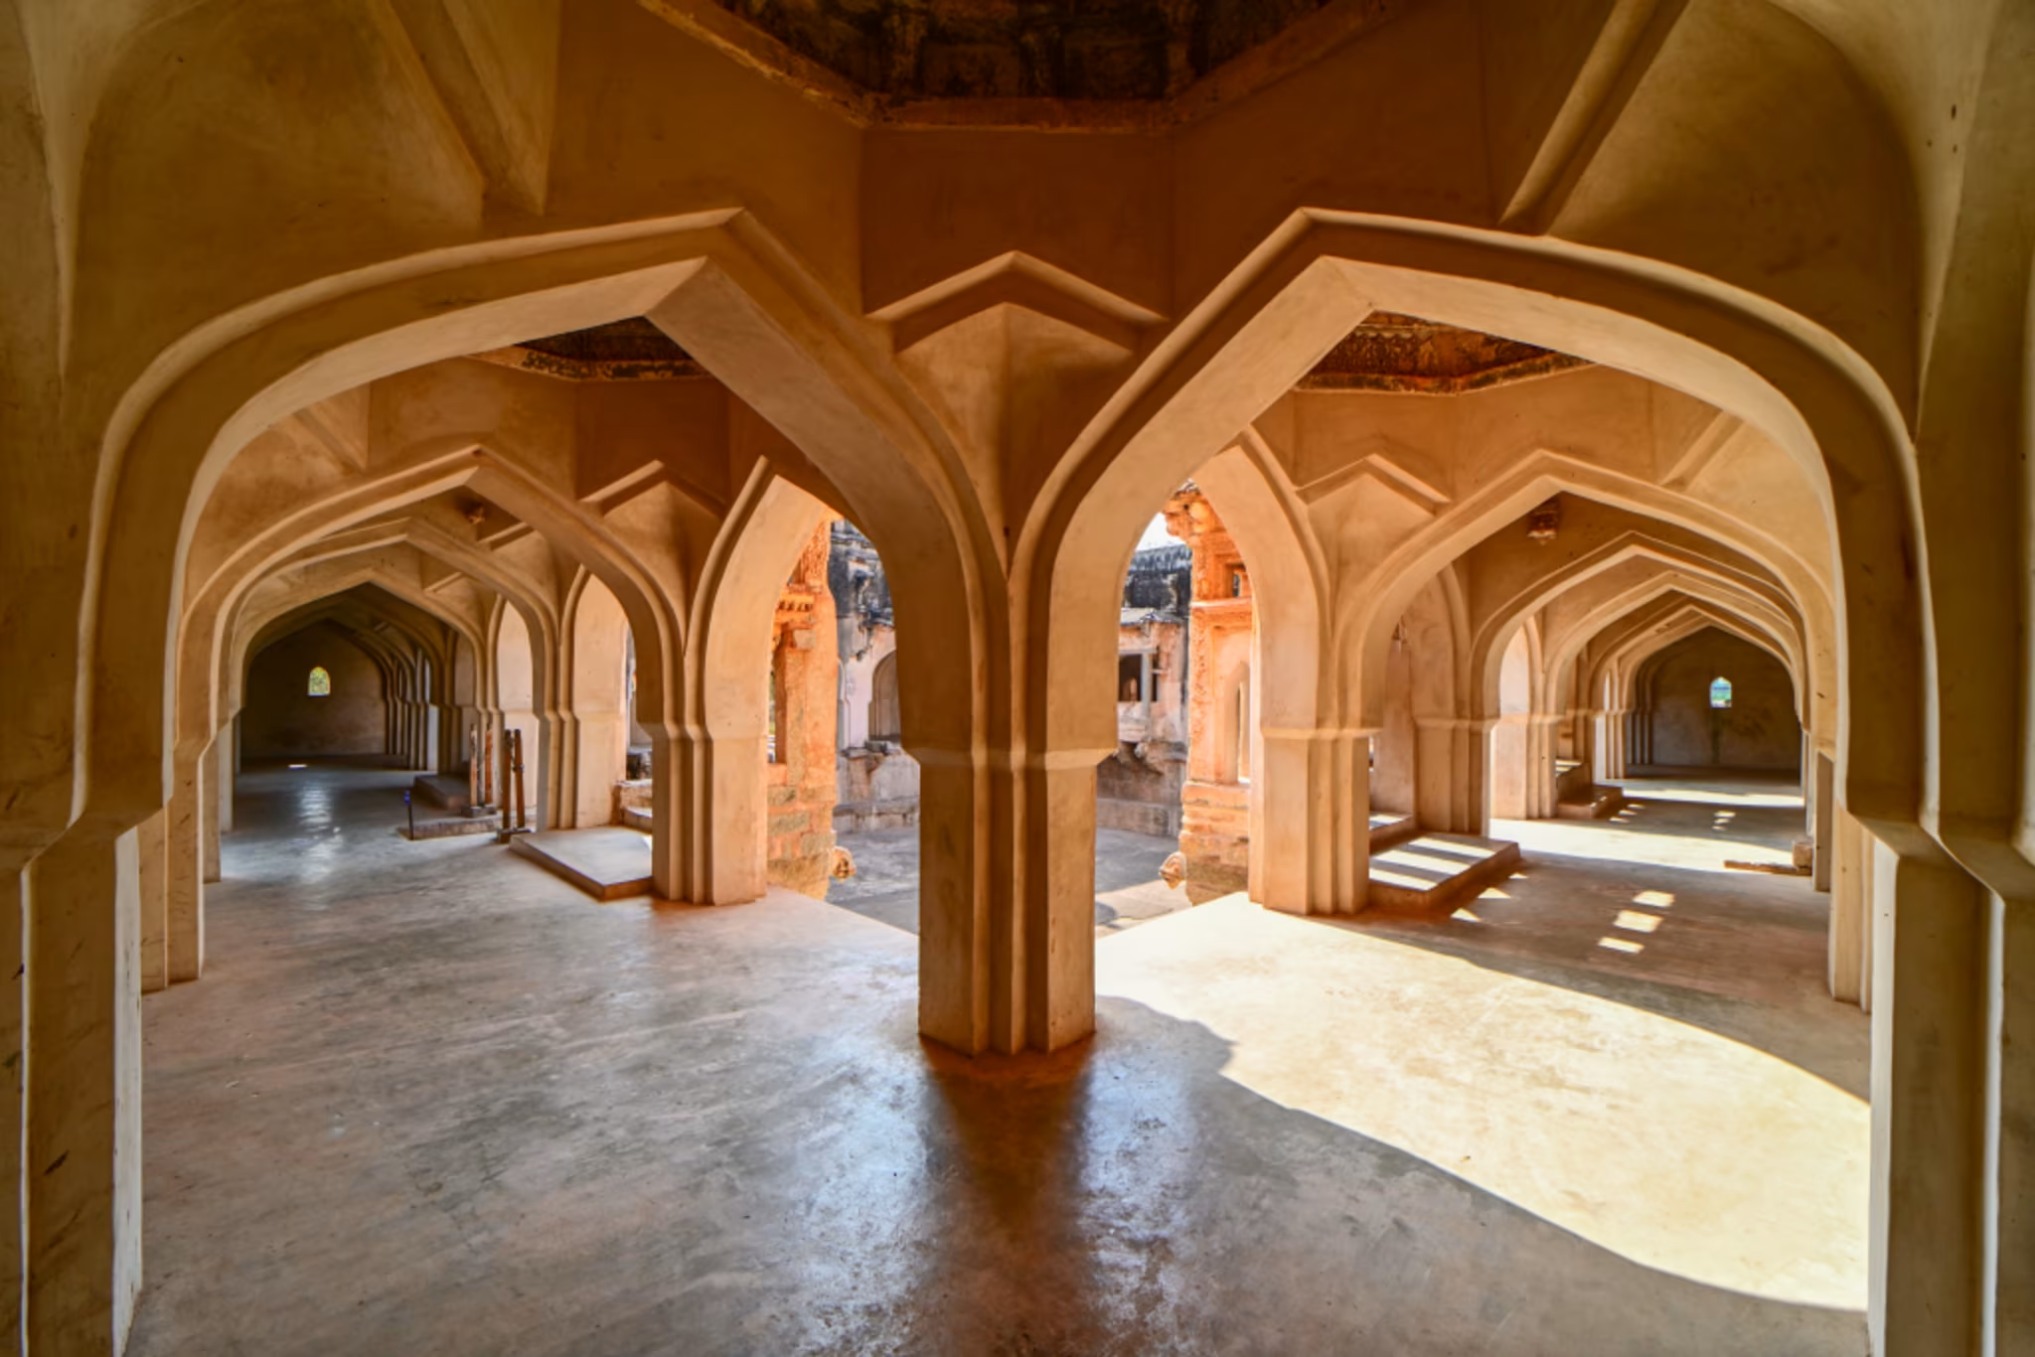

Matanga Hill
Matanga Hill is considered the highest point in Hampi. The hill is famous for offering some of the most breathtaking panoramic views of the entire landscape. Visitors often climb the hill early in the morning to watch the sunrise over the ruins and the Tungabhadra River. The climb involves walking through rocky paths and ancient steps, but the view from the top is worth the effort.
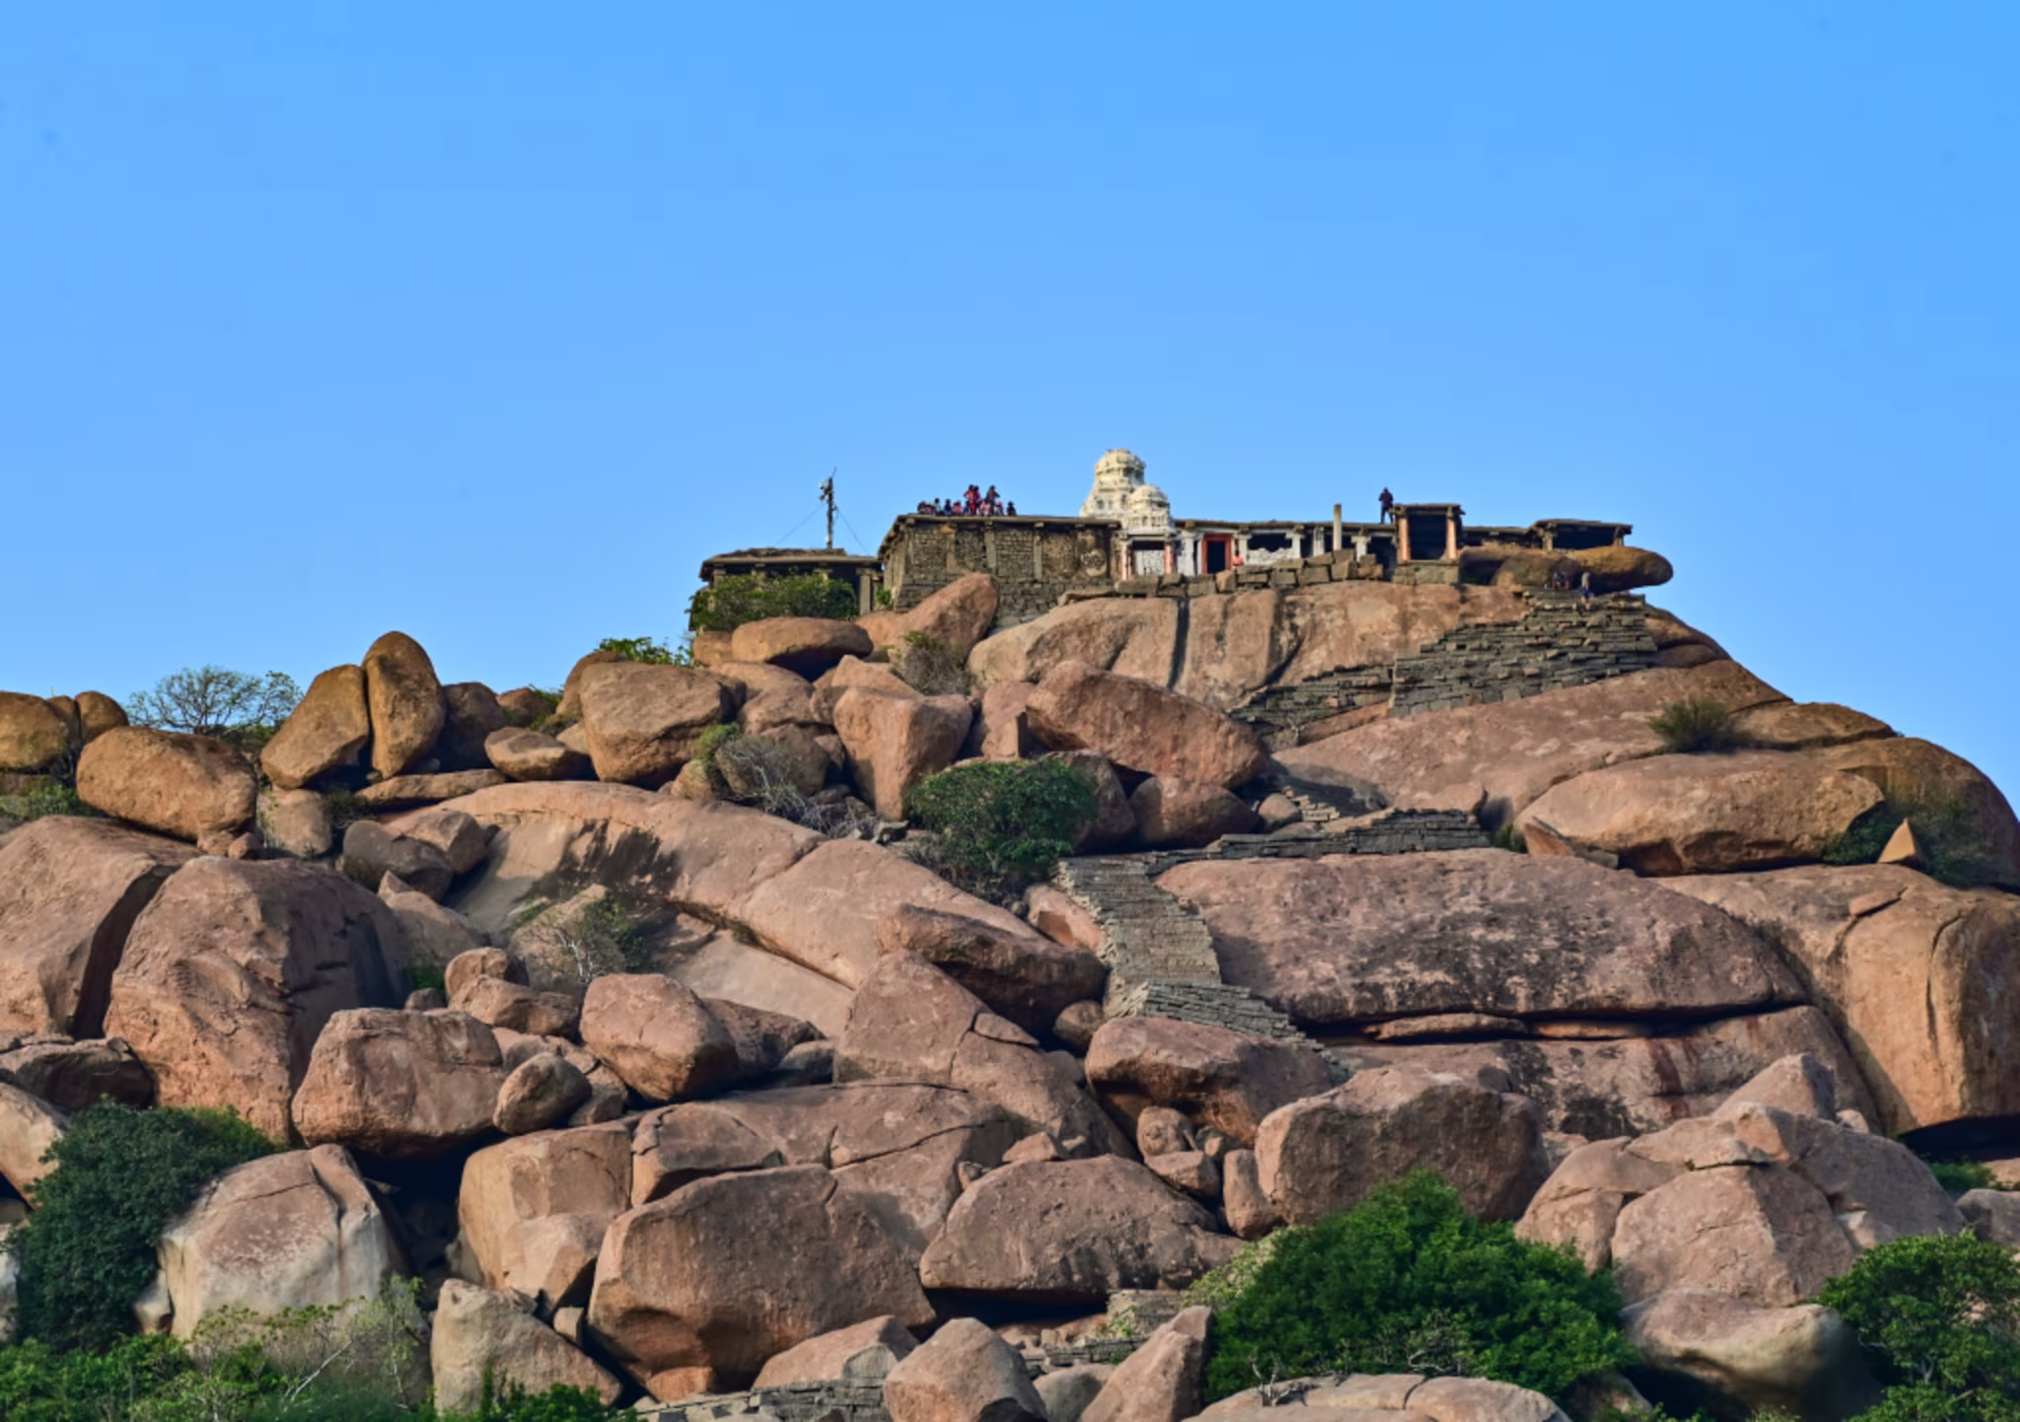

Sasivekalu Ganesha
Artisans carved the Sasivekalu Ganesha as a large statue of Lord Ganesha from a single rock. The statue is about 2.4 meters tall and is located on the slopes of Hemakuta Hill. The name “Sasivekalu” refers to mustard seeds, as the shape of the deity’s belly resembles a mustard seed. The statue is placed inside an open pavilion supported by pillars.
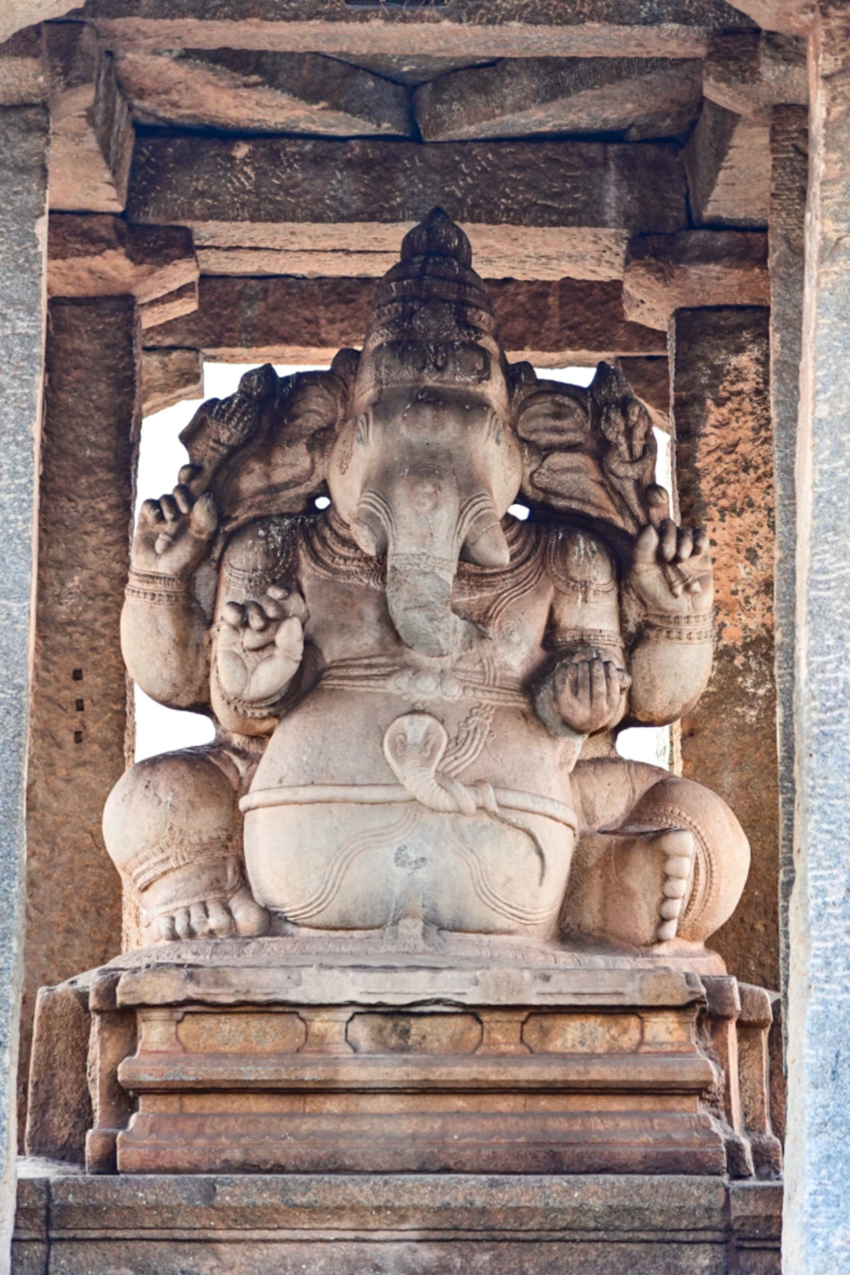

Hampi Bazaar
Hampi Bazaar is one of the most historically significant areas in Hampi. During the peak of the Vijayanagara Empire, the bazaar was a vibrant commercial center. Traders from different regions gathered here to sell valuable goods such as precious stones, silk, spices, and horses. Historical accounts mention that traders traded diamonds and pearls in this busy market street.
Today, the bazaar appears as a long stretch of stone pavilions and ruined mandapas lining both sides of the road. Although the market is no longer active, the remains still reflect the importance of trade in the ancient city.

Things to Do in Hampi
Visitors to Hampi can enjoy several experiences beyond exploring temples and ruins. The dramatic boulder landscape and the scenic Tungabhadra River create opportunities for relaxing and adventurous activities.

Coracle Boat Ride
Take a traditional round coracle boat ride on the Tungabhadra River and enjoy scenic views of the rocky landscape.

Cycling Through the Ruins
Rent a bicycle and explore the vast heritage site at your own pace. Many monuments and viewpoints can be easily reached this way.

Rock Climbing
Hampi’s natural granite boulders make it a well-known spot for rock climbing and bouldering enthusiasts.

Sunrise and Sunset Views
Climb viewpoints like Matanga Hill to enjoy stunning sunrise or sunset views across the ruins.

Visit Hippie Island
The nearby village of Virupapur Gadde, often called Hippie Island, is known for its relaxed atmosphere, cafés, and scenic surroundings.

Best Time to Visit Hampi
The best time to visit Hampi is during the cooler months when Hampi weather is pleasant and comfortable for sightseeing. Winter (October – February) is the best season to explore Hampi. The Hampi temperature ranges between 15°C and 30°C, making it ideal for visiting monuments and outdoor activities.

Festivals & Events in Hampi
Several cultural events and festivals are celebrated in Hampi, attracting visitors from across the country. These events highlight the rich traditions and heritage of the region.

Hampi Utsav
The most famous festival in Hampi, usually held between November and January. The event features cultural performances, music, dance shows, and traditional processions set against the historic ruins.
Know more about the Hampi Utsav

Religious Celebrations
Festivals at the Virupaksha Temple, especially during Maha Shivaratri, attract large numbers of devotees and visitors.

How to Reach Hampi
Hampi is well connected by air, rail, and road, making it accessible from major cities in Karnataka and nearby states.
- By Air: The nearest airport is Jindal Vijaynagar Airport, about 40 km from Hampi. The nearest international airport is Kempegowda International Airport.
- By Train: The nearest railway station to Hampi is Hosapete Junction, located about 13 km away.
- By Road: Hampi has good road connectivity. The Bangalore to Hampi distance is about 340 km, which takes around 6–7 hours by car or bus.
Local taxis, buses, and rental bikes are available from Hosapete to reach Hampi and nearby attractions.

Where to Stay in Hampi
Visitors traveling to Hampi can find a variety of accommodation options suitable for different budgets and travel preferences. The area offers everything from comfortable guesthouses and homestays to modern hotels and luxury resorts. Many travelers prefer staying within Hampi to experience the historic surroundings and easy access to major monuments.

Places to Visit Near Hampi
Several interesting destinations can be explored around Hampi. These places offer scenic landscapes, wildlife experiences, and historic sites.

Tungabhadra Dam (Hosapete)
A popular viewpoint located about 15 km from Hampi, known for its gardens and scenic reservoir views.
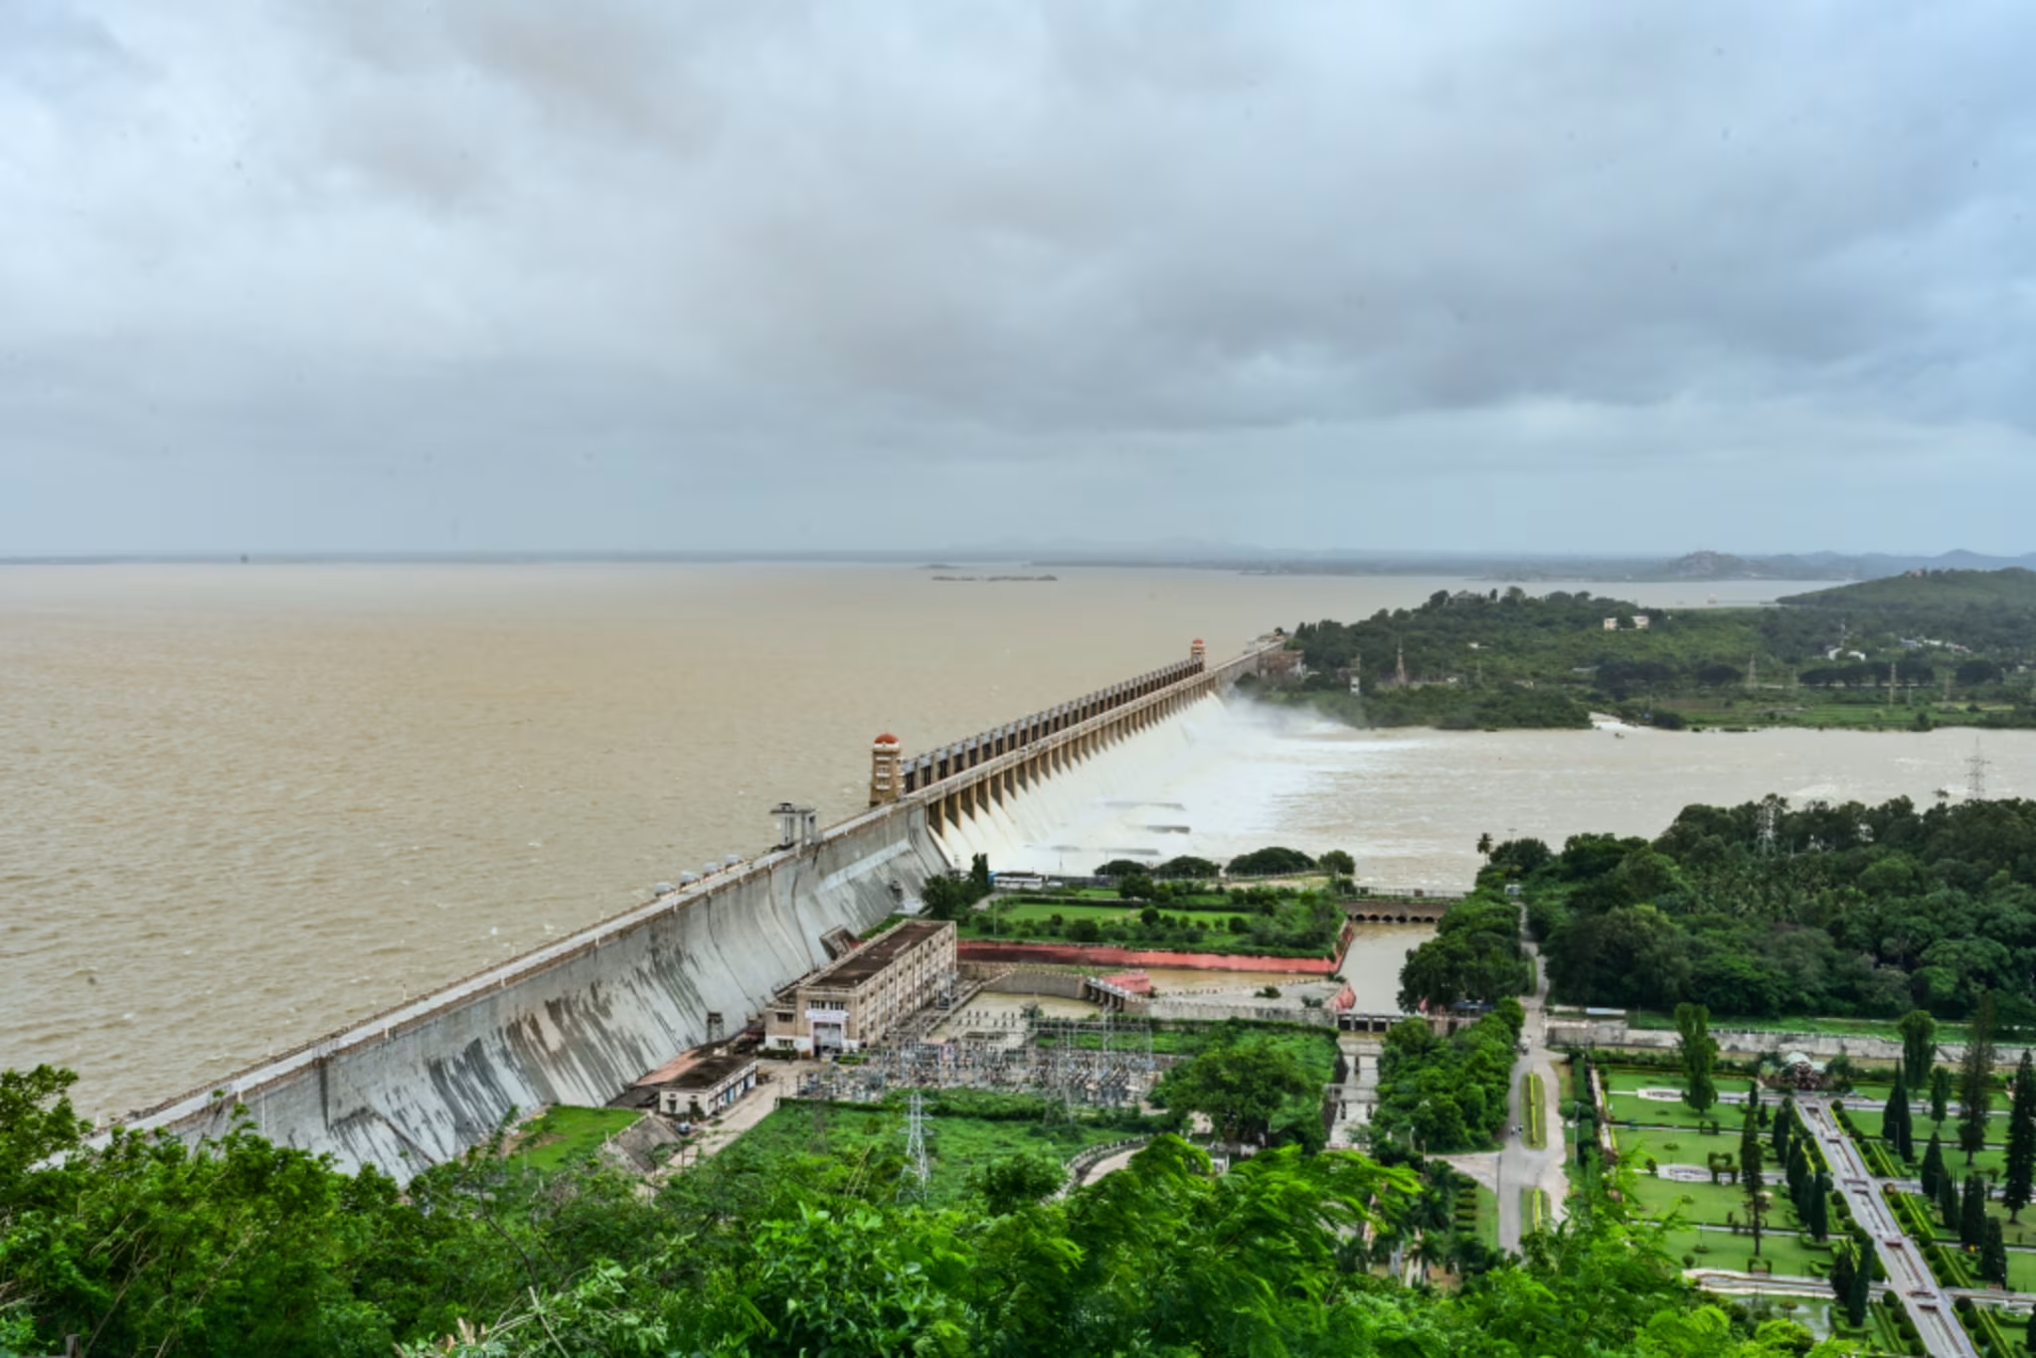

Anegundi
Anegundi is a heritage village across the Tungabhadra River, believed to be older than Hampi and associated with stories from the Ramayana.

Daroji Sloth Bear Sanctuary
Located about 25 km away, this sanctuary protects Indian sloth bears and other wildlife.

Sanapur Lake
A scenic lake popular for coracle rides, cliff jumping, and sunset views.

Nearby Districts to Explore

Ballari District
Home to Hampi and known for historic temples and mining heritage.

Koppal District
Known for historic sites like Anegundi and ancient forts.

Vijayanagara District
A historically significant region named after the Vijayanagara Empire.

Gadag District
Famous for historic temples and traditional architecture.

Experience Hampi
Where silent stones echo with stories of kings, craftsmen, and devotion, Hampi invites you to slow down, look closer, and walk through the grandeur of Karnataka’s timeless past. Visitors can explore the heritage site by walking through the ruins, cycling across the historic landscape, or taking the Hampi Buggy Train to conveniently see several important monuments. Each experience reveals a different side of this remarkable UNESCO World Heritage destination.

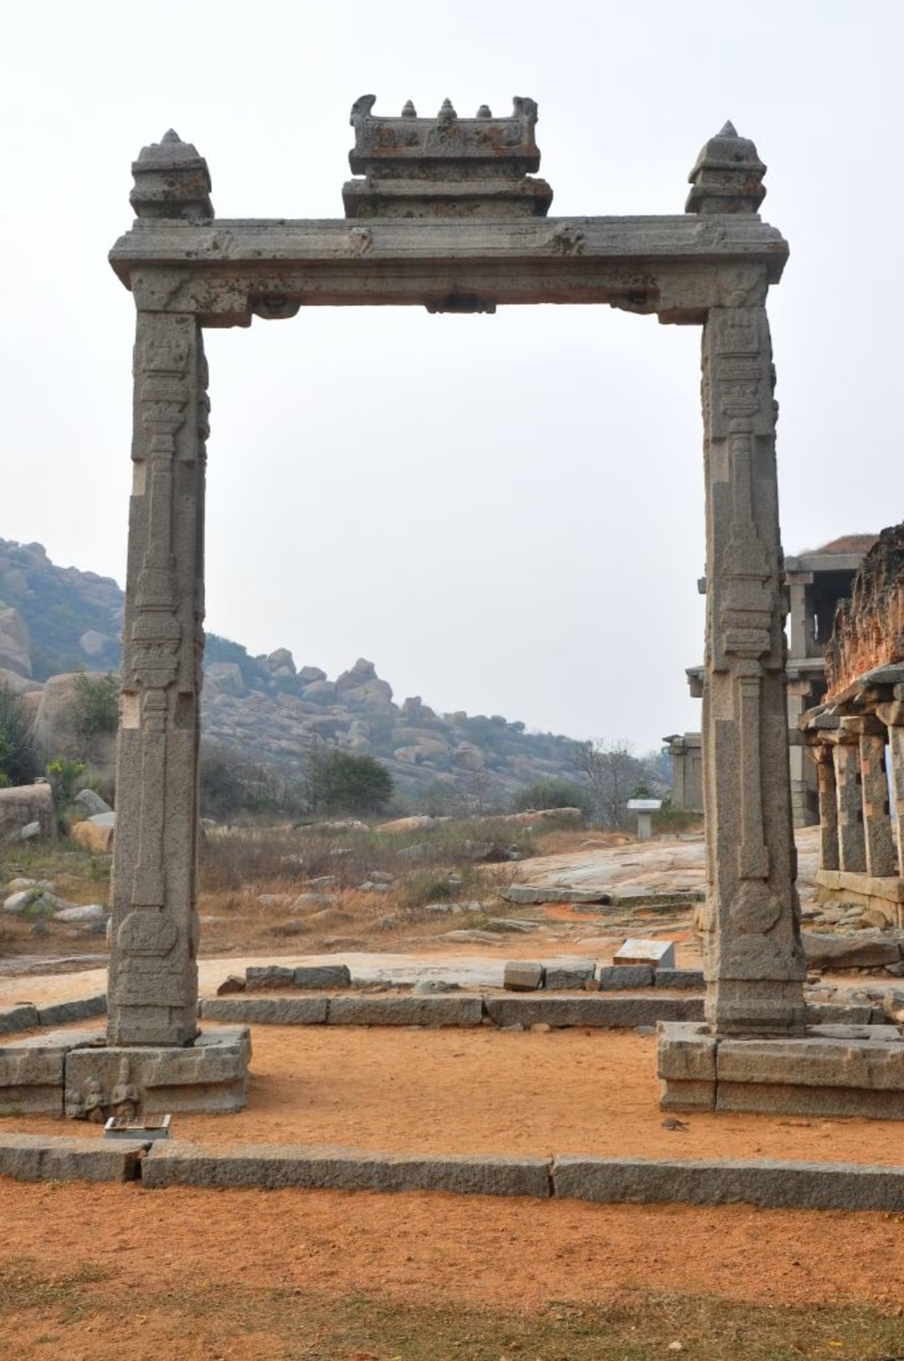

FAQ

Where is Hampi located?
Hampi is located in Ballari District in the state of Karnataka, along the banks of the Tungabhadra River. It lies about 340 km from Bengaluru.

What is Hampi famous for?
Hampi is famous for its ancient ruins, temples, and unique boulder landscapes. It was once the capital of the Vijayanagara Empire and is known for monuments such as the Stone Chariot, Virupaksha Temple, and Lotus Mahal.

What is the best time to visit Hampi?
The best time to visit Hampi is between October and February, when the weather is cooler and comfortable for exploring monuments and outdoor attractions.

What is the nearest railway station to Hampi?
The nearest railway station is Hosapete Junction, located about 13 km from Hampi.

How far is Hampi from Bangalore?
The distance between Bengaluru and Hampi is approximately 340 km, and the journey usually takes 6–7 hours by road.

What is the Stone Chariot in Hampi?
The Stone Chariot is an iconic granite structure located inside the Vijaya Vittala Temple complex.What is Lotus Mahal in Hampi?
The Lotus Mahal stands as a unique structure in the royal enclosure area of Hampi. Its lotus-shaped design and blend of Hindu and Indo-Islamic architectural styles make it well known.

Is Hampi a UNESCO World Heritage Site?
Yes, UNESCO declared Hampi a World Heritage Site in 1986 because of its exceptional historical and architectural significance.

How many days are needed to explore Hampi?
Visitors typically need 2 to 3 days to explore Hampi comfortably, covering its major temples, monuments, and landscapes at a relaxed pace.

What is the entry fee for Hampi temples?
Most temples in Hampi are free to enter. However, monuments like the Vijaya Vittala Temple have an entry fee of around ₹40 for Indian visitors and ₹600 for foreign tourists (subject to change).

